Top of Form

Question 1: Skipped

Identify the missing word(s) in the following sentence within the context of Microsoft Azure.

Setting Global parameters in an Azure Data Factory pipeline … [?]

* ​

cannot be overridden if you wish to use continuous integration and deployment process.

* ​

references to an attribute like a dataset or data flow, this reroutes default parameter values through the resource parameter.

* ​

allows you to use constants for consumption in pipeline expressions.

**(Correct)**

* ​

None of the listed options.

**Explanation**

**Global parameters in Azure Data Factory**

**Setting Global parameters in an Azure Data Factory pipeline,** **allows you to use constants for consumption in pipeline expressions.**A use-case for setting global parameters is when you have multiple pipelines where the parameters names and values are identical. If you use the continuous integration and deployment process with Azure Data Factory, the global parameters can be overridden if you wish so, for each and every environment that you have created.

**Using global parameters in a pipeline**

When using global parameters in a pipeline in Azure Data Factory, it is mostly referenced in pipeline expressions. For example, if a pipeline references to a resource like a dataset or data flow, you can pass down the global parameter value through the resource parameter. The command or reference of global parameters in Azure Data Factory flows as follows: pipeline().globalParameters.

**Global parameters in CI/CD**

When you integrate global parameters in a pipeline using CI/CD with Azure Data Factory, you have two ways in order to do so:

• Include global parameters in the Azure Resource Manager template

• Deploy global parameters via a PowerShell script

In most CI/CD practices, it is beneficial to include global parameters in the Azure Resource Manager template. The reason why it's recommended is of the native integration with CI/CD where global parameters are added as an Azure Resource Manager Template parameter due to changes in several environments that are worked in. In order to enable global parameters in an Azure Resource Manager template, you navigate to the management hub. You do have to be aware that once you add global parameters to an Azure Resource Manager template, it adds an Azure Data Factory level setting, which can override other settings like git configs.

The use case for deploying global parameters through a PowerShell script, could be because you might have the above mentioned settings enabled in an elevated environment like UAT or PROD.

**Parameterize mapping dataflows**

Within Azure Data Factory, you are able to use mapping data flows and therefore, enabling you to use parameters. If you set parameters inside a data flow definition, you can use the parameters in expressions. The parameter values will be set by the calling pipeline through the Execute Data Flow activity.

There are three options for setting the values in the data flow activity expressions:

• Use the pipeline control flow expression language to set a dynamic value

• Use the data flow expression language to set a dynamic value

• Use either expression language to set a static literal value

The reason for parameterizing mapping data flows, is to make sure that your data flows are generalized, flexible, and reusable.

<https://docs.microsoft.com/en-us/azure/data-factory/parameterize-linked-services>

Bottom of Form

Top of Form

Question 2: Skipped

**Scenario:**The company you work at is in the Healthcare industry, which in turn is working with a specific health care provider. This healthcare provider only wants doctors and nurses to be able to access medical records. The billing department should not have access to view this data.

Which type of security would typically be best used in for this scenario?

* ​

Column-level security

**(Correct)**

* ​

Dynamic Data Masking

* ​

Row-level security

* ​

Table-level security

**Explanation**

Authentication is the process of validating credentials as you access resources in a digital infrastructure. This ensures that you can validate that an individual, or a service that wants to access a service in your environment can prove who they are. Azure Synapse Analytics provides several different methods for authentication.

**Column level security in Azure Synapse Analytics**

Generally speaking, column level security is simplifying a design and coding for the security in your application. It allows you to restrict column access in order to protect sensitive data. For example, if you want to ensure that a specific user 'Leo' can only access certain columns of a table because he's in a specific department. The logic for 'Leo' only to access the columns specified for the department he works in, is a logic that is located in the database tier, rather on the application level data tier. If he needs to access data from any tier, the database should apply the access restriction every time he tries to access data from another tier. The reason for doing so, is to make sure that your security is reliable and robust since we're reducing the surface area of the overall security system. Column level security will also eliminate the necessity for the introduction of view, where you would filter out columns, to impose access restrictions on 'Leo'

The way to implement column level security, is by using the GRANT T-SQL statement. Using this statement, SQL and Azure Active Directory (AAD) support the authentication.

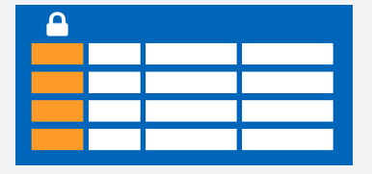

The syntax to use for implementing column level security looks as follows:

SQL

GRANT <permission> [ ,...n ] ON

[ OBJECT :: ][ schema_name ]. object_name [ ( column [ ,...n ] ) ] // specifying the column access

TO <database_principal> [ ,...n ]

[ WITH GRANT OPTION ]

[ AS <database_principal> ]

<permission> ::=

SELECT

| UPDATE

<database_principal> ::=

Database_user // specifying the database user

| Database_role // specifying the database role

| Database_user_mapped_to_Windows_User

| Database_user_mapped_to_Windows_Group

So when would you use column-level security? Let's say that you are a financial services firm, and can only have account manager allowed to have access to a customer's social security number, phone numbers or other personal identifiable information. It is imperative to distinguish the role of an account manager versus the manager of the account managers.

Another use case might be related to the Healthcare Industry. Let's say you have a specific health care provider. This healthcare provider only wants doctors and nurses to be able to access medical records. The billing department should not have access to view this data. Column-level security would typically be the option to use.

**Row level security in Azure Synapse Analytics**

Row-level security (RLS) can help you to create a group membership or execution context in order to control not just columns in a database table, but actually, the rows. RLS, just like column-level security, can simply help and enable your design and coding of your application security. However, compared to column-level security where it's focused on the columns (parameters), RLS helps you implement restrictions on data row access. Let's say that your employee can only access rows of data that are important of the department, you should implement RLS. If you want to restrict for example, customer's data access that is only relevant to the company, you can implement RLS. The restriction on access of the rows, is a logic that is located in the database tier, rather on the application level data tier. If 'Leo' needs to access data from any tier, the database should apply the access restriction every time he tries to access data from another tier. The reason for doing so, is to make sure that your security is reliable and robust since we're reducing the surface area of the overall security system.

The way to implement RLS is by using the CREATE SECURITY POLICY[!INCLUDEtsql] statement. The predicates are created as inline table-valued functions. It is imperative to understand that within Azure Synapse, it only supports filter predicates. If you need to use a block predicate, you won't be able to find support at this moment within in Azure synapse.

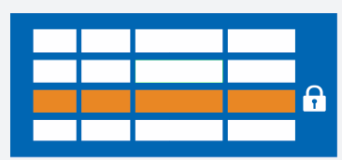

**Description of row level security in relation to filter predicates**

RLS within Azure Synapse supports one type of security predicates, which are Filter predicates, not block predicates.  
What filter predicates do, are silently filtering the rows that are available for read operations such as SELECT, UPDATE, DELETE.

The access to row-level data in a table, is restricted as an inline table-valued function, which is a security predicate. This table-valued function will then be invoked and enforced by the security policy that you need. An application, is not aware of rows that are filtered from the result set for filter predicates. So what will happen is that if all rows are filtered, a null set is returned.

When you are using filter predicates, it will be applied when data is read from the base table. The filter predicate affects all get operations such as SELECT, DELETE, UPDATE. You are unable to select or delete rows that have been filtered. It is not possible for you to update a row that has been filtered. What you can do, is update rows in a way that they will be filtered afterwards.

**Permissions**

If you want to create, alter or drop the security policies, you would have to use the ALTER ANY SECURITY POLICY permission. The reason for that is when you are creating or dropping a security policy it requires ALTER permissions on the schema.

In addition to that, there are other permissions required for each predicate that you would add:

**•**SELECT and REFERENCES permissions on the inline table-valued function being used as a predicate.

**•**REFERENCES permission on the table that you target to be bound to the policy.

**•**REFERENCES permission on every column from the target table used as arguments.

Once you've set up the security policies, they will apply to all the users (including dbo users in the database) Even though DBO users can alter or drop security policies, their changes to the security policies can be audited. If you have special circumstances where highly privileged users, like a sysadmin or db_owner, need to see all rows to troubleshoot or validate data, you would still have to write the security policy in order to allow that.

If you have created a security policy where SCHEMABINDING = OFF, in order to query the target table, the user must have the SELECT or EXECUTE permission on the predicate function. They also need permissions to any additional tables, views, or functions used within the predicate function. If a security policy is created with SCHEMABINDING = ON (the default), then these permission checks are bypassed when users query the target table.

**Best practices**

There are some best practices to take in mind when you want to implement RLS. We recommended creating a separate schema for the RLS objects. RLS objects in this context would be the predicate functions, and security policies. Why is that a best practice? It helps to separate the permissions that are required on these special objects from the target tables. In addition to that, separation for different policies and predicate functions may be needed in multi-tenant-databases. However, it is not a standard for every case.

Another best practice to bear in mind is that the ALTER ANY SECURITY POLICY permission should only be intended for highly privileged users (such as a security policy manager). The security policy manager should not require **SELECT** permission on the tables they protect.

In order to avoid potential runtime errors, you should take in mind type conversions in predicate functions that you write. Also, you should try to avoid recursion in predicate functions. The reason for this is to avoid performance degradation. Even though the query optimizer will try to detect the direct recursions, there is no guarantee to find the indirect recursions. With an indirect recursion we mean where a second function call the predicate function.

It would also be recommended to avoid the use of excessive table joins in predicate functions. This would maximize performance.

Generally speaking when it comes to the logic of predicates, you should try to avoid logic that depends on session-specific SET options. Even though this is highly unlikely to be used in practical applications, predicate functions whose logic depends on certain session-specific **SET** options can leak information if users are able to execute arbitrary queries. For example, a predicate function that implicitly converts a string to **datetime** could filter different rows based on the SET DATEFORMAT option for the current session.

<https://docs.microsoft.com/en-us/azure/synapse-analytics/sql-data-warehouse/column-level-security>

Bottom of Form

Top of Form

Question 3: Skipped

Identify the missing word(s) in the following sentence within the context of Microsoft Azure.

[?] logs every operation Azure Storage account activity in real time, and you can search the logs for specific requests. Filter based on the authentication mechanism, the success of the operation, or the resource that was accessed.

* ​

Application Security Groups

* ​

Storage Analytics

**(Correct)**

* ​

Advanced Data Security

* ​

Network Security Groups

* ​

Azure Advanced Threat Protection

**Explanation**

**Auditing access**

Auditing is another part of controlling access. You can audit Azure Storage access by using the built-in Storage Analytics service.

Storage Analytics logs every operation in real time, and you can search the Storage Analytics logs for specific requests. Filter based on the authentication mechanism, the success of the operation, or the resource that was accessed.

<https://docs.microsoft.com/en-us/azure/storage/common/storage-analytics>

Bottom of Form

Top of Form

Question 4: Skipped

How do you cache data into the memory of the local executor for instant access?

* ​

.inMemory().save()

* ​

.cacheLocalExe()

* ​

.cache()

**(Correct)**

* ​

.save().inMemory()

**Explanation**

The .cache() method is an alias for .persist(). Calling this moves data into the memory of the local executor.

<https://docs.microsoft.com/en-us/azure/databricks/delta/optimizations/delta-cache>

Bottom of Form

Top of Form

Question 5: Skipped

Azure Synapse Analytics supports querying both relational (dedicated and serverless SQL endpoints) and non-relational data (Azure Data Lake Storage Gen 2, Cosmos DB and Azure Blob Storage) at petabyte-scale using Transact SQL, supporting ANSI-compliant SQL language.

The Azure Synapse SQL query language supports different features based on the resource model being used.

Which of the below have support in both relational and non-relational data types? (Select all that apply)

* ​

DDL statements (CREATE, ALTER, DROP)

**(Correct)**

* ​

UPDATE statement

* ​

Data export

**(Correct)**

* ​

Built-in functions (analysis)

**(Correct)**

* ​

Control of flow

**(Correct)**

* ​

SELECT statement

**(Correct)**

* ​

MERGE statement

* ​

DELETE statement

* ​

Built-in functions (text)

**(Correct)**

* ​

INSERT statement

**Explanation**

Azure Synapse Analytics supports querying both relational (dedicated and serverless SQL endpoints) and non-relational data (Azure Data Lake Storage Gen 2, Cosmos DB and Azure Blob Storage) at petabyte-scale using Transact SQL, supporting ANSI-compliant SQL language.

The Azure Synapse SQL query language supports different features based on the resource model being used. The table below outlines which Transact-SQL statements work against each resource model.

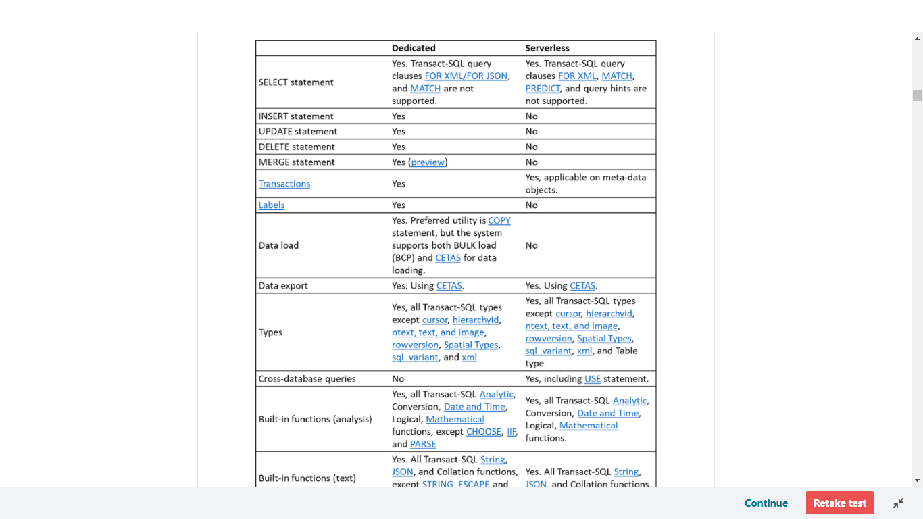

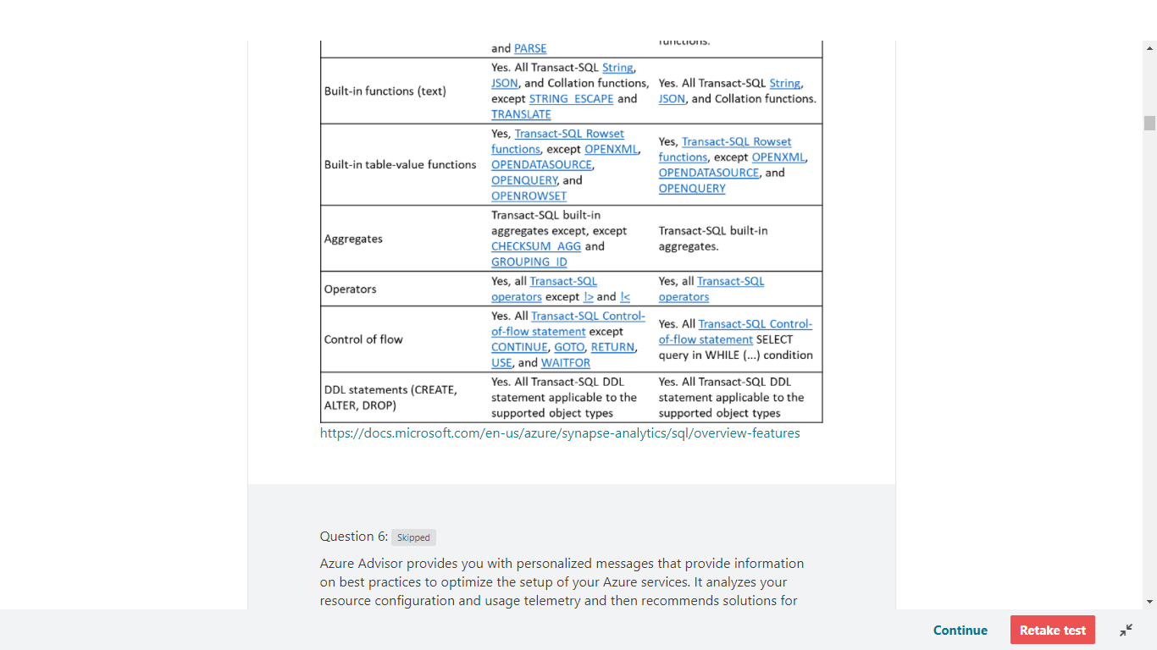

<https://docs.microsoft.com/en-us/azure/synapse-analytics/sql/overview-features>

Bottom of Form

Top of Form

Question 6: Skipped

Azure Advisor provides you with personalized messages that provide information on best practices to optimize the setup of your Azure services. It analyzes your resource configuration and usage telemetry and then recommends solutions for which of the following Azure metrics? (Select all that apply)

* ​

Encryption deficiencies

* ​

Performance

**(Correct)**

* ​

Cost effectiveness

**(Correct)**

* ​

Reliability (formerly called High availability)

**(Correct)**

* ​

Security

**(Correct)**

**Explanation**

Azure Advisor provides you with personalized messages that provide information on best practices to optimize the setup of your Azure services. It analyzes your resource configuration and usage telemetry and then recommends solutions that can help you improve the cost effectiveness, performance, Reliability (formerly called High availability), and security of your Azure resources.

The Advisor may appear when you log into the Azure Portal, but you can also access the Advisor by selecting Advisor in the navigation menu.

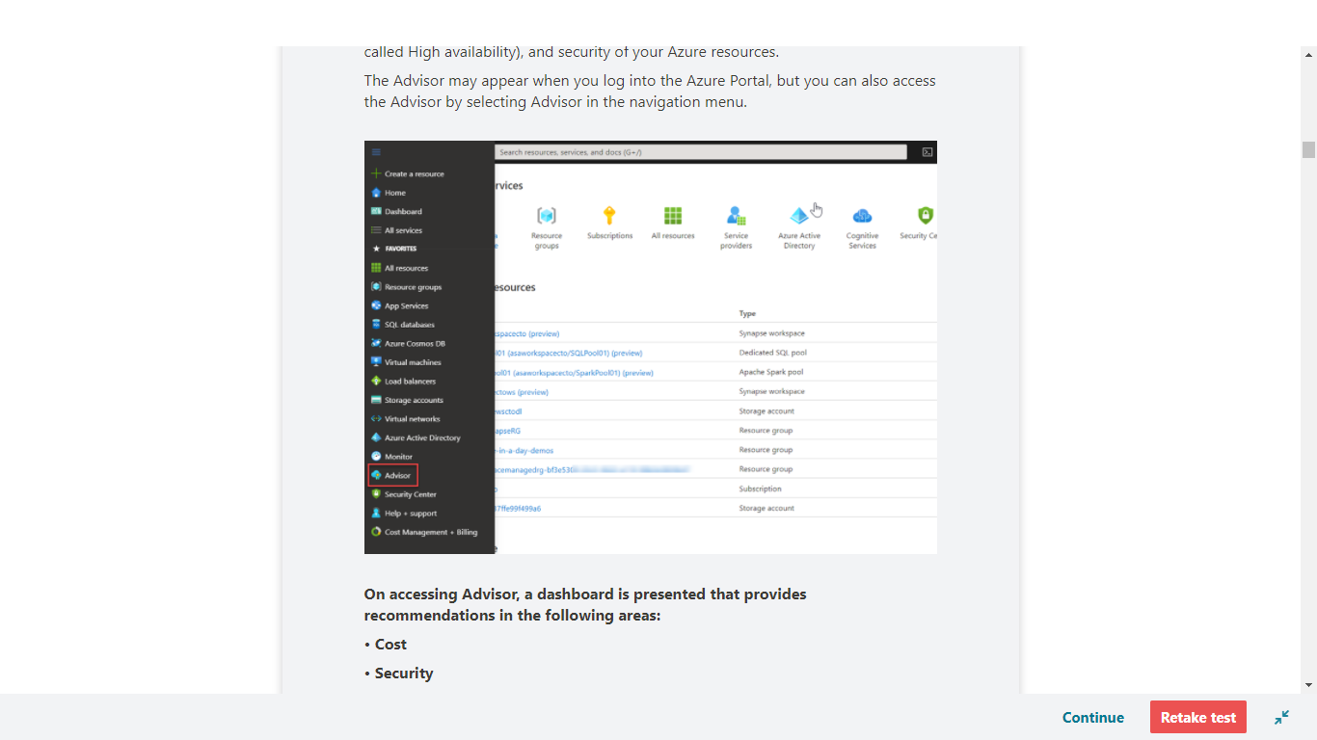

**On accessing Advisor, a dashboard is presented that provides recommendations in the following areas:**

**• Cost**

**• Security**

**• Reliability**

**• Operational excellence**

**• Performance**

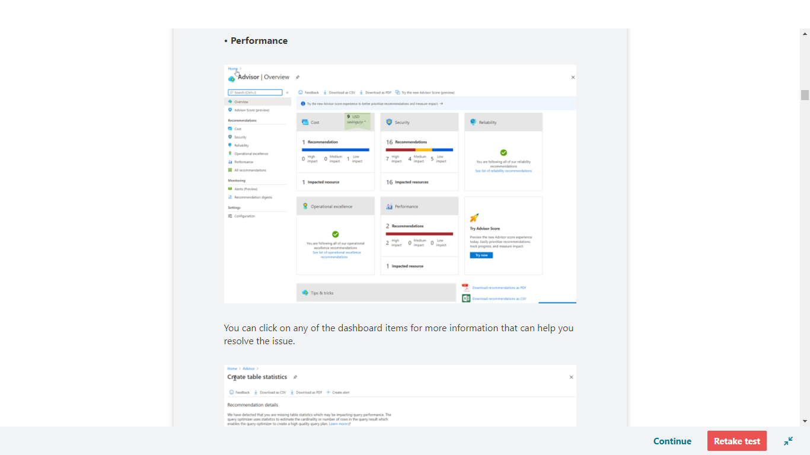

You can click on any of the dashboard items for more information that can help you resolve the issue.

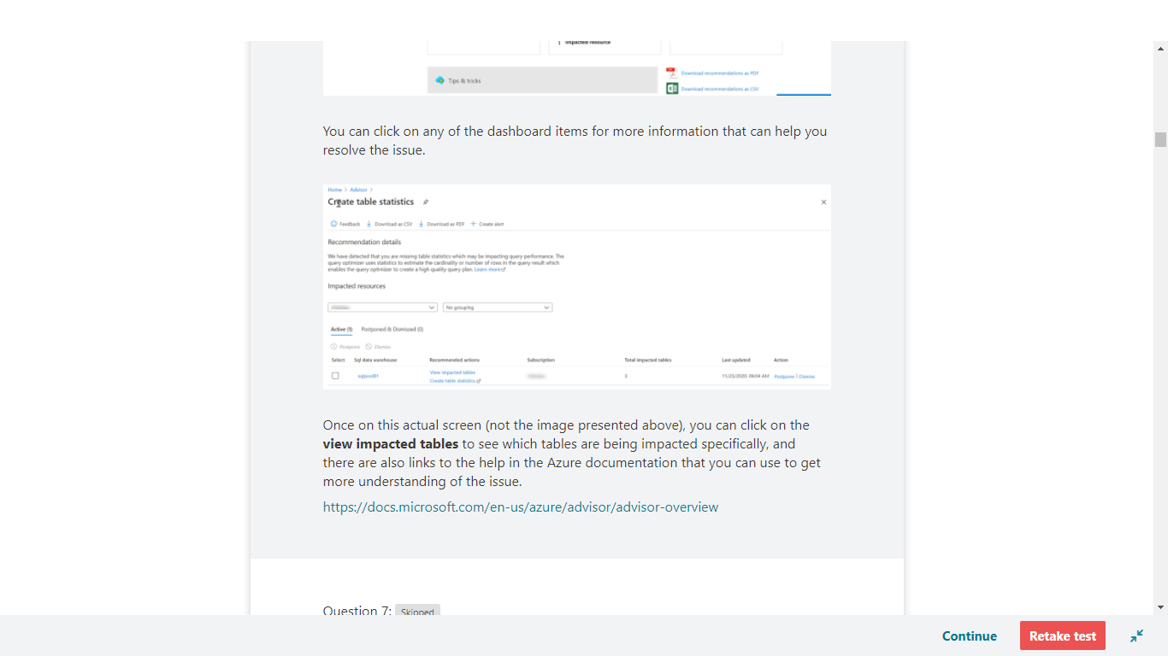

Once on this actual screen (not the image presented above), you can click on the **view impacted tables** to see which tables are being impacted specifically, and there are also links to the help in the Azure documentation that you can use to get more understanding of the issue.

<https://docs.microsoft.com/en-us/azure/advisor/advisor-overview>

Bottom of Form

Top of Form

Question 7: Skipped

**Scenario:**O'Shaughnessy's is a fast food restaurant. The chain has stores nationwide and is rivalled by Big Belly Burgers. You have been hired by the company to advise on working with Microsoft Azure Data Lake Storage.

At the moment, the team is planning the deployment of Azure Data Lake Storage Gen2.

There are two reports which will access the data lake:

**• Report1:** Reads three columns from a file that contains 50 columns.

**• Report2:** Queries a single record based on a timestamp.

As the Azure expert, the team is looking for you to recommend in which format to store the data in the data lake to support the reports. The solution must minimize read times.

**The options available are:**

a. AVRO

b. CSV

c. Parquet

d. TSV

Which should you recommend to O'Shaughnessy's for each report?

* ​

Report1: Parquet, Report2: AVRO

**(Correct)**

* ​

Report1: CSV, Report2: Parquet

* ​

Report1: Parquet, Report2: TSV

* ​

Report1: CSV, Report2: TSV

**Explanation**

**Report1:** Parquet - column-oriented binary file format

Parquet format is supported for the following connectors: [Amazon S3](https://docs.microsoft.com/en-us/azure/data-factory/connector-amazon-simple-storage-service), [Amazon S3 Compatible Storage](https://docs.microsoft.com/en-us/azure/data-factory/connector-amazon-s3-compatible-storage), [Azure Blob](https://docs.microsoft.com/en-us/azure/data-factory/connector-azure-blob-storage), [Azure Data Lake Storage Gen1](https://docs.microsoft.com/en-us/azure/data-factory/connector-azure-data-lake-store), [Azure Data Lake Storage Gen2](https://docs.microsoft.com/en-us/azure/data-factory/connector-azure-data-lake-storage), [Azure File Storage](https://docs.microsoft.com/en-us/azure/data-factory/connector-azure-file-storage), [File System](https://docs.microsoft.com/en-us/azure/data-factory/connector-file-system), [FTP](https://docs.microsoft.com/en-us/azure/data-factory/connector-ftp), [Google Cloud Storage](https://docs.microsoft.com/en-us/azure/data-factory/connector-google-cloud-storage), [HDFS](https://docs.microsoft.com/en-us/azure/data-factory/connector-hdfs), [HTTP](https://docs.microsoft.com/en-us/azure/data-factory/connector-http), [Oracle Cloud Storage](https://docs.microsoft.com/en-us/azure/data-factory/connector-oracle-cloud-storage) and [SFTP](https://docs.microsoft.com/en-us/azure/data-factory/connector-sftp).

<https://docs.microsoft.com/en-us/azure/data-factory/format-parquet>

**Report2:**AVRO - Row based format, and has logical type timestamp

The Azure Data Lake Storage Gen2 destination writes data to Azure Data Lake Storage Gen2 based on the data format that you select. You can use the following data formats:

Avro The destination writes records based on the Avro schema. You can use one of the following methods to specify the location of the Avro schema definition: In Pipeline Configuration - Use the schema that you provide in the stage configuration. In Record Header - Use the schema included in the avroSchema record header attribute. Confluent Schema Registry - Retrieve the schema from Confluent Schema Registry. Confluent Schema Registry is a distributed storage layer for Avro schemas. You can configure the destination to look up the schema in Confluent Schema Registry by the schema ID or subject.

If using the Avro schema in the stage or in the record header attribute, you can optionally configure the destination to register the Avro schema with Confluent Schema Registry.

The destination includes the schema definition in each file. You can compress data with an Avro-supported compression codec. When using Avro compression, avoid using other compression properties in the destination.

<https://streamsets.com/documentation/datacollector/latest/help/datacollector/UserGuide/Destinations/ADLS-G2-D.html>



<https://youtu.be/UrWthx8T3UY>

Bottom of Form

Top of Form

Question 8: Skipped

Identify the missing word(s) in the following sentence within the context of Microsoft Azure.

Within an Apache Spark Pool it is possible to configure a fixed size when you disable autoscaling. When you enable autoscale, you can set a minimum and maximum number of nodes in order to control the scale that you'd like. Once you have enabled autoscale, Synapse Analytics will monitor the resource load.

It will continuously monitoring CPU usage, pending memory, free CPU, free memory, and the used memory per node for scaling decisions. It checks these metrics every [?] seconds and makes scaling decisions based on the values.

* ​

30

**(Correct)**

* ​

90

* ​

60

* ​

120

* ​

45

**Explanation**

Within an Apache Spark Pool it is possible to configure a fixed size when you disable autoscaling. When you enable autoscale, you can set a minimum and maximum number of nodes in order to control the scale that you'd like. Once you have enabled autoscale, Synapse Analytics will monitor for you the requirement of resources of the load. Accordingly, it will scale the number of nodes up or down. There will be continuously monitoring depending on CPU usage, pending memory, free CPU, free memory, and the used memory per node when it comes to the metrics involved to make a decision to scale up or down.**It checks these metrics every 30 seconds and makes scaling decisions based on the values. There's no additional charge for this feature.**

To make it a bit more simple for you, details are below that show the metrics that autoscale enablement of the Spark Pool within Azure Synapse analytics instance checks and collects:

• Total Pending CPU

The total number of cores required to start execution of all pending nodes.

• Total Pending Memory

The total memory (in MB) required to start execution of all pending nodes.

• Total Free CPU

The sum of all unused cores on the active nodes.

• Total Free Memory

The sum of unused memory (in MB) on the active nodes.

• Used Memory per Node

The load on a node. A node on which 10 GB of memory is used, is considered under more load than a worker with 2 GB of used memory.

**The metrics will be checked every 30 seconds and the autoscale function will base it decisions of scale-up and scale-down accordingly.**

When we look at load-based scale conditions, the autoscale functionality will issue a scale request based on the metrics outlined in the details below:

**Scale-up**

• Total pending CPU is greater than total free CPU for more than 1 minute.

• Total pending memory is greater than total free memory for more than 1 minute.

**Scale-down**

• Total pending CPU is less than total free CPU for more than 2 minutes.

• Total pending memory is less than total free memory for more than 2 minutes.

When autoscale, scales up, it will calculate the number of new nodes that would be needed in order to meet the CPU and memory requirements. Next, it will issue the scale-up requests and add the number of nodes required to do the job.

In case autoscale performs the action of scaling down, the decision is based on the number of executors as well as application primaries per node and the CPU and memory requirements. The autoscale functionality will then issue the request to remove a certain number of nodes. What the autoscale functionality will also do, is check which nodes are candidates for removal based on the current job execution. The scale down operation first decommissions the nodes, and then removes them from the cluster.

If you'd like to get started with the autoscale functionality, you'd have to follow the next steps:

**Create a serverless Apache Spark pool with Autoscaling**

To enable the Autoscale feature, complete the following steps as part of the normal pool creation process:

1.On the **Basics** tab, select the **Enable autoscale** checkbox.

2.Enter the desired values for the following properties:

**• Min** number of nodes.

**• Max** number of nodes.

The initial number of nodes will be the minimum. This value defines the initial size of the instance when it's created. The minimum number of nodes can't be fewer than three.

When we look at the best practices in use for the autoscale feature, consider latency as part of the scale up or down operations. It could take 1 to 5 minutes in order for the scaling operations (whether that's scaling up or down) to complete. Also, when you scale down, the nodes will first be put in decommission state such that there won't be new executors launching on the node. The jobs that are still running, will continue to run and finish, however, the pending jobs will be in a waiting state to be scheduled as normal but with fewer nodes.

<https://docs.microsoft.com/en-us/azure/synapse-analytics/spark/apache-spark-overview>

Bottom of Form

Top of Form

Question 9: Skipped

Identify the missing word(s) in the following sentence within the context of Microsoft Azure.

Azure Synapse Analytics can work by acting as the one stop shop to meet all of your analytical needs in an integrated environment.

[?] offers both serverless and dedicated resource models to work with both descriptive and diagnostic analytical scenarios. This is a distributed query system that enables you to implement data warehousing and data virtualization scenarios using standard T-SQL.

* ​

Azure Cosmos DB

* ​

Azure Synapse Link

* ​

Azure Synapse SQL

**(Correct)**

* ​

Azure Synapse Pipelines

* ​

Apache Spark for Azure Synapse

**Explanation**

Azure Synapse Analytics can work by acting as the one stop shop to meet all of your analytical needs in an integrated environment. It does this by providing the following capabilities:

**Analytics capabilities offered through Azure Synapse SQL through either dedicated SQL pools or SQL Serverless pools**

Azure Synapse SQL is a distributed query system that enables you to implement data warehousing and data virtualization scenarios using standard T-SQL experiences familiar to data engineers. Synapse SQL offers both serverless and dedicated resource models to work with both descriptive and diagnostic analytical scenarios. For predictable performance and cost, create dedicated SQL pools to reserve processing power for data stored in SQL tables. For unplanned or ad-hoc workloads, use the always-available, serverless SQL endpoint.

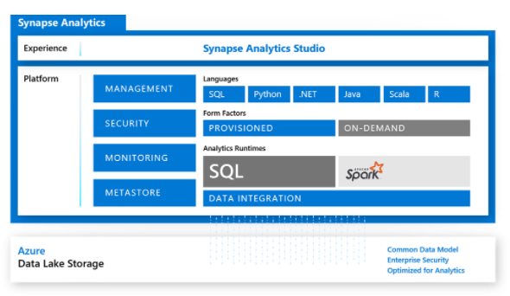

**Apache Spark pool with full support for Scala, Python, SparkSQL, and C#**

You can develop big data engineering and machine learning solutions using Apache Spark for Azure Synapse. You can take advantage of the big data computation engine to deal with complex compute transformations that would take too long in a data warehouse. For machine learning workloads, you can use SparkML algorithms and AzureML integration for Apache Spark 2.4 with built-in support for Linux Foundation Delta Lake. There is a simple model for provisioning and scaling the Spark clusters to meet your compute needs, regardless of the operations that you are performing on the data.

**Data integration to integrate your data with Azure Synapse Pipelines**

Azure Synapse Pipelines leverages the capabilities of Azure Data Factory and is the cloud-based ETL and data integration service that allows you to create data-driven workflows for orchestrating data movement and transforming data at scale. Using Azure Synapse Pipelines, you can create and schedule data-driven workflows (called pipelines) that can ingest data from disparate data stores. You can build complex ETL processes that transform data visually with data flows or by using compute services such as Azure HDInsight Hadoop, or Azure Databricks.

**Perform operational analytics with near real-time hybrid transactional and analytical processing with Azure Synapse Link**

Azure Synapse Analytics enables you to reach out to operational data using Azure Synapse Link, and is achieved without impacting the performance of the transactional data store. For this to happen, you have to enable the feature within both Azure Synapse Analytics, and within the data store to which Azure Synapse Analytics will connect, such as Azure Cosmos DB. In the case of Azure Cosmos DB, this will create an analytical data store. As data changes in the transactional system, the changed data is fed to the analytical store in a Column store format from which Azure Synapse Link can query with no disruption to the source system.

<https://docs.microsoft.com/en-us/azure/synapse-analytics/overview-what-is>

Bottom of Form

Top of Form

Question 10: Skipped

What command should be issued to view the list of active streams?

* ​

Invoke spark.streams.show

* ​

Invoke spark.streams.active

**(Correct)**

* ​

Invoke spark.view.activeStreams

* ​

Invoke spark.view.active

**Explanation**

Invoke spark.streams.active which is the correct syntax to view the list of active streams.

<https://spark.apache.org/docs/latest/structured-streaming-programming-guide.html>

Bottom of Form

Top of Form

Question 11: Skipped

Identify the missing word(s) in the following sentence within the context of Microsoft Azure.

Apache Spark is an open-source distributed system that is used for processing big data workloads.

To achieve this capability, … [?]

* ​

None of the listed options.

* ​

Spark automatically adjusts based on your requirements, freeing you up from managing your infrastructure and picking the right size for your solution.

* ​

Spark enables ad hoc data preparation scenarios, where organizations are wanting to unlock insights from their own data stores without going through the formal processes of setting up a data warehouse.

* ​

Spark performs predictive analytics using both the native features of Azure Synapse Analytics, and integrating with other technologies such as Azure Databricks.

* ​

Spark pools clusters are groups of computers that are treated as a single computer and handle the execution of commands issued from notebooks.

**(Correct)**

**Explanation**

Apache Spark is an open-source distributed system that is used for processing big data workloads. Big data workloads are defined as workloads to handle data that is too large or complex for traditional database systems. Apache Spark processes large amounts of data in memory, which boosts the performance of analyzing big data more effectively, and this capability is available within Azure Synapse Analytics, and is referred to as Spark pools.

**To achieve this capability, Spark pools clusters are groups of computers that are treated as a single computer and handle the execution of commands issued from notebooks.**The clusters allow processing of data to be parallelized across many computers to improve scale and performance. It consists of a Spark Driver and Worker nodes. The Driver node sends work to the Worker nodes and instructs them to pull data from a specified data source. Moreover, you can configure the number of nodes that are required to perform the task.

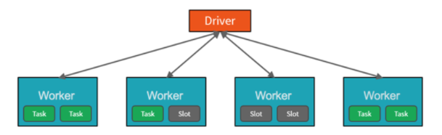

Spark pools in Azure Synapse Analytics offer a fully managed Spark service. The benefits of creating a Spark pool in Synapse Analytics include.

**Speed and efficiency**

Spark instances start in approximately 2 minutes for fewer than 60 nodes and approximately 5 minutes for more than 60 nodes. The instance shuts down, by default, 5 minutes after the last job executed unless it is kept alive by a notebook connection.

**Ease of creation**

You can create a new Spark pool in Azure Synapse in minutes using the Azure portal, Azure PowerShell, or the Synapse Analytics .NET SDK.

**Ease of use**

Synapse Analytics includes a custom notebook derived from Nteract. You can use these notebooks for interactive data processing and visualization.

**Scalability**

Apache Spark in Azure Synapse pools can have Auto-Scale enabled, so that pools scale by adding or removing nodes as needed. Also, Spark pools can be shut down with no loss of data since all the data is stored in Azure Storage or Data Lake Storage.

**Support for Azure Data Lake Storage Generation 2**

Spark pools in Azure Synapse can use Azure Data Lake Storage Generation 2 as well as BLOB storage.

The primary use case for Apache Spark for Azure Synapse Analytics is to process big data workloads that cannot be handled by Azure Synapse SQL, and where you don’t have an existing Apache Spark implementation.

Perhaps you must perform a complex calculation on large volumes of data. Handling this requirement in Spark pools will be far more efficient than in Synapse SQL. You can pass the data through to the Spark cluster to perform the calculation, and then pass the processed data back into the data warehouse, or back to the data lake.

If you already have a Spark implementation in place already, Azure Synapse Analytics can also integrate with other Spark implementations such as Azure Databricks, so you don’t have to use the feature in Azure Synapse Analytics if you already have a Spark setup already.

Finally, Spark pools in Azure Synapse Analytics come with Anaconda libraries pre-installed. Anaconda provides close to 200 libraries that enables you to use the spark pool to perform machine learning, data analysis, and data visualization. This can enable data scientists and data analysts to interact with the data using the Spark pool too.

<https://docs.microsoft.com/en-us/azure/synapse-analytics/spark/apache-spark-overview>

Bottom of Form

Top of Form

Question 12: Skipped

**Scenario:**You are the team lead working on a project and a new team member joins your group. He proceeds to review options for an input to an Azure Stream Analytics job your team is working on which requires low latencies and high throughput. He seems uncertain which input he should be using so your ask him *“Which Azure product do you plan to use for the job's input?”*

What should his answer be?

* ​

Azure Event Hubs

**(Correct)**

* ​

Azure Table Storage

* ​

Azure Data Lake Storage

* ​

Azure Queue Storage

* ​

Azure Blob storage

* ​

Azure IoT Hub

**Explanation**

Event Hubs consumes data streams from applications at low latencies and high throughput.

<https://docs.microsoft.com/en-us/azure/event-hubs/event-hubs-about>

Bottom of Form

Top of Form

Question 13: Skipped

Azure Storage provides a REST API to work with the containers and data stored in each account. To work with data in a storage account, your app will need which pieces of data? (Select two)

* ​

Subscription key

* ​

Public access key

* ​

REST API endpoint

**(Correct)**

* ​

Instance key

* ​

Access key

**(Correct)**

* ​

Private access key

**Explanation**

Azure Storage provides a REST API to work with the containers and data stored in each account. To work with data in a storage account, your app will need two pieces of data:

• Access key

• REST API endpoint

**Security access keys**

Each storage account has two unique *access keys* that are used to secure the storage account. If your app needs to connect to multiple storage accounts, your app will require an access key for each storage account.

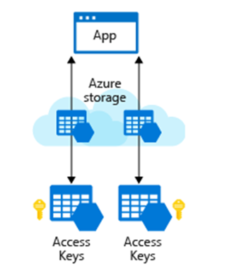

**REST API endpoint**

In addition to access keys for authentication to storage accounts, your app will need to know the storage service endpoints to issue the REST requests.

The REST endpoint is a combination of your storage account *name*, the data type, and a known domain. For example:

**Data type:**Blobs

**Example endpoint:**https://[name].blob.core.windows.net/

**Data type:**Queues

**Example endpoint:**https://[name].queue.core.windows.net/

**Data type:**Table

**Example endpoint:** https://[name].table.core.windows.net/

**Data type:**Files

**Example endpoint:**https://[name].file.core.windows.net/

If you have a custom domain tied to Azure, then you can also create a custom domain URL for the endpoint.

<https://docs.microsoft.com/en-us/rest/api/storageservices/blob-service-rest-api>

Bottom of Form

Top of Form

Question 14: Skipped

**Scenario:**You have started at a new job at a company which has a Data Lake Storage Gen2 account. You have been tasked with uploading a single file to the account and you want to use a tool that you don't have to install or configure.

Which tool should you choose?

* ​

Azure Data Catalogue

* ​

Azure Storage Explorer

* ​

Azure Data Studio

* ​

Azure Data Factory

* ​

The Azure Portal

**(Correct)**

**Explanation**

The **Azure Portal** requires no installation or configuration. To upload a file, you only have to sign in and a select an Upload button.

<https://docs.microsoft.com/en-us/azure/storage/files/storage-how-to-use-files-portal>

Bottom of Form

Top of Form

Question 15: Skipped

Azure Data Factory is composed of four core components. These components work together to provide the platform on which you can compose data-driven workflows with steps to move and transform data.

Which component is best described by:

*“It has information on the different data sources and Data Factory uses this information to connect to data originating sources. It is mainly used to locate the data stores in the machines and also represent the compute services for the activity to be executed, such as running spark jobs on spark clusters or running hive queries using hive services from the cloud.”*

* ​

Linked service

**(Correct)**

* ​

Pipeline

* ​

Activity

* ​

Dataset

**Explanation**

An Azure subscription might have one or more Azure Data Factory instances. Azure Data Factory is composed of four core components. These components work together to provide the platform on which you can compose data-driven workflows with steps to move and transform data.

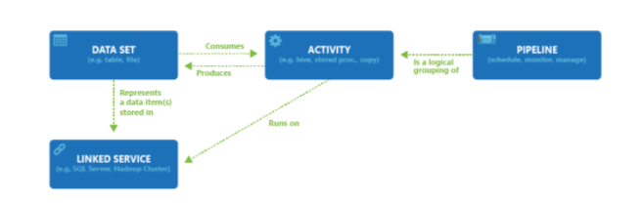

**• Pipeline:** It is created to perform a specific task by composing the different activities in the task in a single workflow. Activities in the pipeline can be data ingestion (Copy data to Azure) -> data processing (Perform Hive Query). Using pipeline as a single task user can schedule the task and manage all the activities in a single process also it is used to run the multiple operation parallel. Multiple activities can be logically grouped together with an object referred to as a **Pipeline**, and these can be *scheduled* to execute, or a *trigger* can be defined that determines when a pipeline execution needs to be kicked off. There are different types of triggers for different types of events.

**• Activity:** It is a specific action performed on the data in a pipeline like the transformation or ingestion of the data. Each pipeline can have one or more activities in it. If the data is copied from one source to destination using Copy Monitor then it is a data movement activity. If data transformation is performed on the data using a hive query or spark job then it is a data transformation activity.

**• Datasets:** It is basically collected data users required which are used as input for the ETL process. Datasets have different formats; they can be in JSON, CSV, ORC, or text format.

**• Linked services:** It has information on the different data sources and the data factory uses this information to connect to data originating sources. It is mainly used to locate the data stores in the machines and also represent the compute services for the activity to be executed like running spark jobs on spark clusters or running hive queries using the hive services from the cloud.

<https://www.educba.com/azure-data-factory/>

Bottom of Form

Top of Form

Question 16: Skipped

**Scenario:**Dr. Karl Malus works for the Power Broker Corporation founded by Curtiss Jackson, using technology to service various countries and their military efforts. You have been contracted by the company to assist Dr. Malus with some Azure Data Lake Storage work.

Dr. Malus has files and folders in Azure Data Lake Storage Gen2 for an Azure Synapse workspace as shown in the following exhibit.

[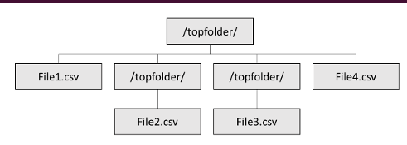](javascript:void(0))

A team member creates an external table named ExtTable that has LOCATION='/topfolder/'.

When Dr. Malus queries ExtTable by using an Azure Synapse Analytics serverless SQL pool, which of the following files are returned? (Select all that apply)

* ​

File2.csv

* ​

File1.csv

**(Correct)**

* ​

File4.csv

**(Correct)**

* ​

File3.csv

**Explanation**

*Serverless SQL pool can recursively traverse folders only if you specify /** at the end of path.*

Serverless SQL pool supports reading multiple files/folders by using wildcards, which are similar to the wildcards used in Windows OS. However, greater flexibility is present since multiple wildcards are allowed.

<https://docs.microsoft.com/en-us/azure/synapse-analytics/sql/query-folders-multiple-csv-files>

In case of a serverless pool a wildcard should be added to the location.

When reading from Parquet files, you can specify only the columns you want to read and skip the rest.

LOCATION = '*folder_or_filepath*'

Specifies the folder or the file path and file name for the actual data in Azure Blob Storage. The location starts from the root folder. The root folder is the data location specified in the external data source.

Unlike Hadoop external tables, native external tables don't return subfolders unless you specify /** at the end of path. In this example, if LOCATION='/webdata/', a serverless SQL pool query, will return rows from mydata.txt. It won't return mydata2.txt and mydata3.txt because they're located in a subfolder. Hadoop tables will return all files within any sub-folder.

Both Hadoop and native external tables will skip the files with the names that begin with an underline (_) or a period (.).

DATA_SOURCE = *external_data_source_name* - Specifies the name of the external data source that contains the location of the external data. To create an external data source, use [CREATE EXTERNAL DATA SOURCE](https://docs.microsoft.com/en-us/azure/synapse-analytics/sql/develop-tables-external-tables?tabs=hadoop#create-external-data-source).

FILE_FORMAT = *external_file_format_name* - Specifies the name of the external file format object that stores the file type and compression method for the external data.

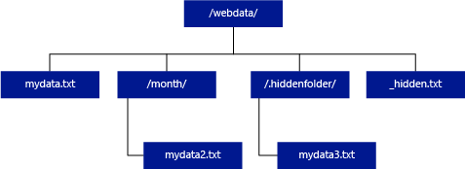

<https://docs.microsoft.com/en-us/azure/synapse-analytics/sql/develop-tables-external-tables?tabs=hadoop#arguments-create-external-table>

Bottom of Form

Top of Form

Question 17: Skipped

Identify the missing word(s) in the following sentence within the context of Microsoft Azure.

Security and infrastructure configuration go hand-in-hand. When you set up your Azure Databricks workspace(s) and related services, you need to make sure that security considerations do not take a back seat during the architecture design.

With regards to the Workspace to VNet ratio, Microsoft recommends … [?]

* ​

that you should deploy at least two workspaces in any VNet.

* ​

that you should only deploy one workspace in any VNet.

**(Correct)**

* ​

that you should deploy a maximum of ten workspaces in any VNet.

* ​

that you should deploy between two and fifteen workspaces in any VNet.

**Explanation**

Security and infrastructure configuration go hand-in-hand. When you set up your Azure Databricks workspace(s) and related services, you need to make sure that security considerations do not take a back seat during the architecture design.

**Consider isolating each workspace in its own VNet**

**While you can deploy more than one Workspace in a VNet by keeping the associated subnet pairs separate from other workspaces, MS recommends that you should only deploy one workspace in any VNet.**Doing this perfectly aligns with the ADB's Workspace level isolation model. Most often organizations consider putting multiple workspaces in the same VNet so that they all can share some common networking resource, like DNS, also placed in the same VNet because the private address space in a VNet is shared by all resources. You can easily achieve the same while keeping the Workspaces separate by following the [hub and spoke model](https://docs.microsoft.com/en-us/azure/architecture/reference-architectures/hybrid-networking/hub-spoke) and using VNet Peering to extend the private IP space of the workspace VNet. Here are the steps:

1.Deploy each Workspace in its own spoke VNet.

2.Put all the common networking resources in a central hub VNet, such as your custom DNS server.

3.Join the Workspace spokes with the central networking hub using [VNet Peering](https://docs.azuredatabricks.net/administration-guide/cloud-configurations/azure/vnet-peering.html)

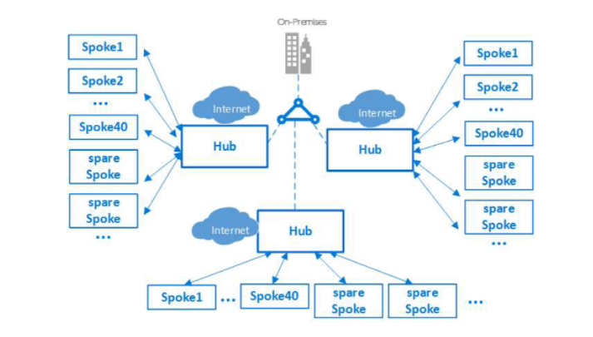

**Do not store any production data in Default Databricks Filesystem (DBFS) Folders**

This recommendation is driven by security and data availability concerns. Every Workspace comes with a default Databricks File System (DBFS), primarily designed to store libraries and other system-level configuration artifacts such as initialization scripts. You should not store any production data in it, because:

1. The lifecycle of default DBFS is tied to the Workspace. Deleting the workspace will also delete the default DBFS and permanently remove its contents.

2. One can't restrict access to this default folder and its contents.

**Important: This recommendation doesn't apply to Blob or ADLS folders explicitly mounted as DBFS by the end user.**

**Always hide secrets in a key vault**

It is a significant security risk to expose sensitive data such as access credentials openly in Notebooks or other places such as job configs, initialization scripts, etc. You should always use a vault to securely store and access them. You can either use ADB's internal Key Vault for this purpose or use Azure's Key Vault (AKV) service.

If using Azure Key Vault, create separate AKV-backed secret scopes and corresponding AKVs to store credentials pertaining to different data stores. This will help prevent users from accessing credentials that they might not have access to. Since access controls are applicable to the entire secret scope, users with access to the scope will see all secrets for the AKV associated with that scope.

**Access control - Azure Data Lake Storage (ADLS) passthrough**

When enabled, authentication automatically takes place in Azure Data Lake Storage (ADLS) from Azure Databricks clusters using the same Azure Active Directory (Azure AD) identity that one uses to log into Azure Databricks. Commands running on a configured cluster will be able to read and write data in ADLS without needing to configure service principal credentials. Any ACLs applied at the folder or file level in ADLS are enforced based on the user's identity.

ADLS Passthrough is configured when you create a cluster in the Azure Databricks workspace. ADLS Gen1 requires Databricks Runtime 5.1+. ADLS Gen2 requires 5.3+.

On a *standard cluster*, when you enable this setting you must set single user access to one of the Azure Active Directory (AAD) users in the Azure Databricks workspace. [Only one user is allowed to run commands](https://docs.microsoft.com/en-us/azure/databricks/data/data-sources/azure/adls-passthrough) on this cluster when Credential Passthrough is enabled.

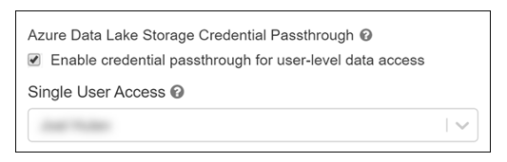

*High-concurrency clusters* can be shared by multiple users. When you enable ADLS Passthrough on this type of cluster, it does not require you to select a single user.

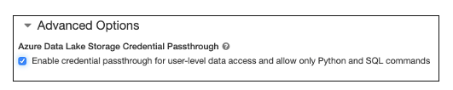

**Configure audit logs and resource utilization metrics to monitor activity**

An important facet of monitoring is understanding the resource utilization in Azure Databricks clusters. You can also extend this to understanding utilization across all clusters in a workspace. This information is useful in arriving at the correct cluster and VM sizes. Each VM does have a set of limits (cores/disk throughput/network throughput) which play an important role in determining the performance profile of an Azure Databricks job.

In order to get utilization metrics of an Azure Databricks cluster, you can stream the VM's metrics to an Azure Log Analytics Workspace (see Appendix A) by installing the Log Analytics Agent on each cluster node.

**Querying VM metrics in Log Analytics once you have started the collection using the above document**

You can use Log analytics directly to query the Perf data. Here is an example of a query which charts out CPU for the VMs in question for a specific cluster ID. See log analytics overview for further documentation on log analytics and query syntax.

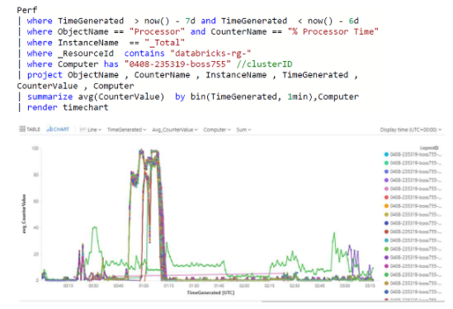

**References**

1.<https://docs.microsoft.com/azure/azure-monitor/learn/quick-collect-linux-computer>

2. <https://github.com/Microsoft/OMS-Agent-for-Linux/blob/master/docs/OMS-Agent-for-Linux.md>

3. <https://github.com/Microsoft/OMS-Agent-for-Linux/blob/master/docs/Troubleshooting.md>

Bottom of Form

Top of Form

Question 18: Skipped

Identify the missing word(s) in the following sentence within the context of Microsoft Azure.

From a high level, the Azure Databricks service launches and manages Apache Spark clusters within your Azure subscription. Apache Spark clusters are groups of computers that are treated as a single computer and handle the execution of commands issued from notebooks.

Microsoft Azure manages the cluster, and [?]

* ​

provides the fastest virtualized network infrastructure in the cloud.

* ​

auto-scales it as needed based on your usage and the setting used when configuring the cluster.

**(Correct)**

* ​

pulls data from a specified data source.

* ​

specifies the types and sizes of the virtual machines.

**Explanation**

To gain a better understanding of how to develop with Azure Databricks, it is important to understand the underlying architecture. We will look at two aspects of the Databricks architecture: the Azure Databricks service and Apache Spark clusters.

**High-level overview**

From a high level, the Azure Databricks service launches and manages Apache Spark clusters within your Azure subscription. Apache Spark clusters are groups of computers that are treated as a single computer and handle the execution of commands issued from notebooks. Using a master-worker type architecture, clusters allow processing of data to be parallelized across many computers to improve scale and performance. They consist of a Spark Driver (master) and worker nodes. The driver node sends work to the worker nodes and instructs them to pull data from a specified data source.

In Databricks, the notebook interface is the driver program. This driver program contains the main loop for the program and creates distributed datasets on the cluster, then applies operations (transformations & actions) to those datasets. Driver programs access Apache Spark through a SparkSession object regardless of deployment location.

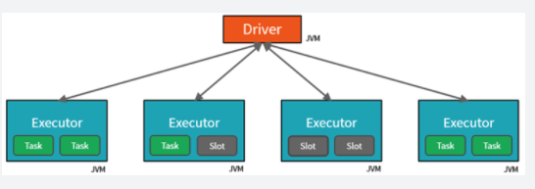

**Microsoft Azure manages the cluster, and auto-scales it as needed based on your usage and the setting used when configuring the cluster.**Auto-termination can also be enabled, which allows Azure to terminate the cluster after a specified number of minutes of inactivity.

**Under the covers**

Now let's take a deeper look under the covers. When you create an Azure Databricks service, a "Databricks appliance" is deployed as an Azure resource in your subscription. At the time of cluster creation, you specify the types and sizes of the virtual machines (VMs) to use for both the Driver and Worker nodes, but Azure Databricks manages all other aspects of the cluster.

You also have the option of using a Serverless Pool. A Serverless Pool is self-managed pool of cloud resources that is auto-configured for interactive Spark workloads. You provide the minimum and maximum number of workers and the worker type, and Azure Databricks provisions the compute and local storage based on your usage.

The "Databricks appliance" is deployed into Azure as a managed resource group within your subscription. This resource group contains the Driver and Worker VMs, along with other required resources, including a virtual network, a security group, and a storage account. All metadata for your cluster, such as scheduled jobs, is stored in an Azure Database with geo-replication for fault tolerance.

Internally, Azure Kubernetes Service (AKS) is used to run the Azure Databricks control-plane and data-planes via containers running on the latest generation of Azure hardware (Dv3 VMs), with NvMe SSDs capable of blazing 100us latency on IO. These make Databricks I/O performance even better. In addition, accelerated networking provides the fastest virtualized network infrastructure in the cloud. Azure Databricks utilizes these features to further improve Spark performance. Once the services within this managed resource group are ready, you will be able to manage the Databricks cluster through the Azure Databricks UI and through features such as auto-scaling and auto-termination.

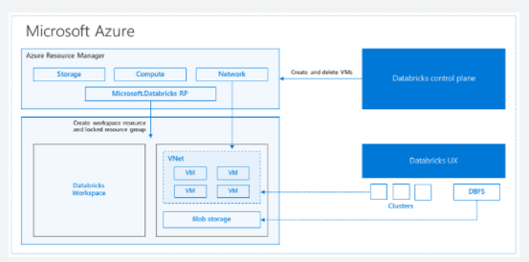

<https://databricks.com/blog/2017/11/15/a-technical-overview-of-azure-databricks.html>

Bottom of Form

Top of Form

Question 19: Skipped

Identify the missing word(s) in the following sentence within the context of Microsoft Azure.

Azure Cosmos DB analytical store is a fully isolated column store for enabling large-scale analytics against operational data in your Azure Cosmos DB, without any impact to your transactional workloads.

There are two schema representation modes for data stored in the analytical store.

• For SQL (Core) API accounts, when analytical store is enabled, the default schema representation in the analytical store is [A].

• For Azure Cosmos DB API for MongoDB accounts, the default schema representation in the analytical store is [B].

* ​

[A] Well-defined schema representation, [B] Full fidelity schema representation

**(Correct)**

* ​

[A] Dynamic schema representation, [B] Static schema representation

* ​

[A] SQLC schema representation, [B] Full fidelity schema representation

* ​

[A] Static schema representation, [B] Dynamic schema representation

* ​

[A] Full fidelity schema representation, [B] Well-defined schema representation

**Explanation**

Azure Cosmos DB analytical store is a fully isolated column store for enabling large-scale analytics against operational data in your Azure Cosmos DB, without any impact to your transactional workloads.

There are two constraints that apply to the schema inferencing done by the autosync process as it transparently maintains the schema in the analytical store based on items added or updated in the transactional store:

• You can have a maximum of unique 1000 properties at any nesting level within the items stored in a transactional store. Any property above this and its associated values will not be present in the analytical store.

• Property names must be unique when compared in a case insensitive manner. For example, the properties {"name": "Franklin Ye"} and {"Name": "Franklin Ye"} cannot exit at the same nesting level in the same item or different items within a container given that “name” and “Name” are not unique when compared in a case insensitive manner.

There are two modes of schema representation for data stored in the analytical store. These modes have tradeoffs between the simplicity of a columnar representation, handling the polymorphic schemas, and simplicity of query experience:

• Well-defined schema representation

• Full fidelity schema representation

**For SQL (Core) API accounts, when analytical store is enabled, the default schema representation in the analytical store is well-defined. Whereas for Azure Cosmos DB API for MongoDB accounts, the default schema representation in the analytical store is full fidelity schema representation.** (If you have scenarios requiring a different schema representation than the default offering for each of these APIs, reach out to the Azure Cosmos DB team to enable it.)

**Well-defined schema representation**

The well-defined schema representation creates a simple tabular representation of the schema-agnostic data in the transactional store as it copies it to the analytical store.

The following code fragment is an example JSON document representing a customer profile record:

JSON

{

"id": "54AB87A7-BDB9-4FAE-A668-AA9F43E26628",

"type": "customer",

"name": "Franklin Ye",

"customerId": "54AB87A7-BDB9-4FAE-A668-AA9F43E26628",

"address": {

"streetNo": 15850,

"streetName": "NE 40th St.",

"postcode": "CR30AA",

}

}

The well-defined schema representation has the top-level properties of the documents exposed as columns when queried from both Synapse SQL and Synapse Spark, along with column values that representing the property values, except in the case where those values are of object type or array type, in which case a JSON representation of the properties values contained within are assigned to the column values.

**Full-fidelity schema representation**

The full-fidelity schema representation creates a more complex tabular representation of the schema-agnostic data in the transactional store as it copies it to the analytical store. The full-fidelity schema representation has the top-level properties of the documents exposed as columns when queried from both Synapse SQL and Synapse Spark along with a JSON representation of the properties values contained within as column values. This is extended to include the data type of the properties along with their property values and as such can better handle polymorphic schemas of operational. With this schema representation, no items are dropped from the analytical store due to the need to meet the well-defined schema rules. For example, let’s take the following sample document in the transactional store:

JSON

{

"id": "54AB87A7-BDB9-4FAE-A668-AA9F43E26628",

"type": "customer",

"name": "Franklin Ye",

"customerId": "54AB87A7-BDB9-4FAE-A668-AA9F43E26628",

"address": {

"streetNo": 15850,

"streetName": "NE 40th St.",

"postcode": "CR30AA",

}

}

<https://docs.microsoft.com/en-us/azure/cosmos-db/analytical-store-introduction>

Bottom of Form

Top of Form

Question 20: Skipped

**Scenario:** You are determining the type of Azure service needed to fit the following specifications and requirements:

**Data classification:** Unstructured

**Operations:**

• Only need to be retrieved by ID.

• Customers require a high number of read operations with low latency.

• Creates and updates will be somewhat infrequent and can have higher latency than read operations.

**Latency & throughput:** Retrievals by ID need to support low latency and high throughput. Creates and updates can have higher latency than read operations.

**Transactional support:** Not required

* ​

Azure Blob Storage

**(Correct)**

* ​

Azure Route Table

* ​

Azure SQL Database

* ​

Azure Queue Storage

* ​

Azure Cosmos DB

**Explanation**

**Recommended service: Azure Blob storage**

Azure Blob storage supports storing files such as photos and videos. It also works with Azure Content Delivery Network (CDN) by caching the most frequently used content and storing it on edge servers. Azure CDN reduces latency in serving up those images to your users.

By using Azure Blob storage, you can also move images from the hot storage tier to the cool or archive storage tier, to reduce costs and focus throughput on the most frequently viewed images and videos.

<https://docs.microsoft.com/en-us/azure/storage/blobs/storage-blobs-introduction>

**Why not other Azure services?**

You could upload your images to Azure App Service, so that the same server that is running your app is serving up your images. This solution would work if you didn't have many files. But if you have lots of files, and a global audience, you'll get more performance results by using Azure Blob storage with Azure CDN.

Bottom of Form

Top of Form

Question 21: Skipped

Knowing now the different concepts of spark it is imperative to understand how it fits in with the different Data services on Azure.

Which of the following is best described by:

*“An implementation by Microsoft of Open Source Spark, managed on the Azure Platform. You can use this for a spark environment when you are aware of the benefits of Apache Spark in its OSS form, but you want an SLA. Usually this is of interest to Open Source Professionals needing an SLA as well as Data Platform experts experienced with Microsoft.”*

* ​

Apache Spark

* ​

Azure Databricks

* ​

HDI

**(Correct)**

* ​

Spark Pools in Azure Synapse Analytics

**Explanation**

There are two concepts within Apache Spark Pools in Azure Synapse Analytics, namely Spark pools and Spark Instances. In short, they do the following:

**Spark Pools:**

• Exists as Metadata

• Creates a Spark Instance

• No costs associated with creating Pool

• Permissions can be applied

• Best practices

**Spark Instances:**

• Created when connected to Spark Pool, Session, or Job

• Multiple users can have access

• Reusable

Knowing now the different concepts of spark it is imperative to understand how it fits in with the different Data services on Azure. Below is a table where "the when to use what" is outlined:

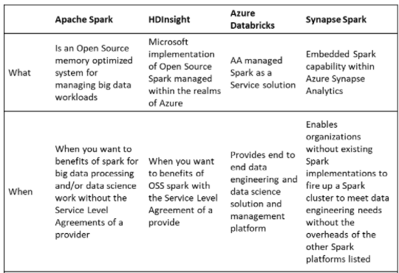

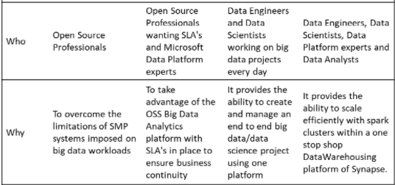

***Spark Pools in Azure Synapse Analytics*:** Spark in Azure Synapse Analytics is a capability of Spark embedded in Azure Synapse Analytics in which organizations that don’t have existing spark implementations yet, get the functionality to spin up a spark cluster to meet data engineering needs without the overhead of the other Spark Platforms listed. Data Engineers, Data scientist, Data Platform Experts, and Data Analyst can come together within Synapse Analytics where the Spark cluster is spun up quickly to meet the needs. It provides scale in an efficient way for Spark Clusters and integrates with the one stop shop Data warehousing platform of Synapse.

***Apache Spark*:** Apache Spark is an open-source memory optimized system for managing big data workloads, which is used when you want a spark engine for big data processing or data science where you don’t mind that there is no SLA provided. Usually it is of interest of Open Source Professionals and the reason for Apache spark is to overcome the limitations of what was known as SMP systems for big data workloads.

***HDI*:** HDI is an implementation by Microsoft of Open Source Spark, managed on the Azure Platform. You can use HDI for a spark environment when you are aware of the benefits of Apache Spark in its OSS form, but you want a SLA. Usually this of interest of Open Source Professionals needing an SLA as well as Data Platform experts experienced with Microsoft.

***Azure Databricks*:**Azure Databricks is a managed Spark as a Service propriety Solution that provides an end to end data engineering/data science platform as a solution. Azure Databricks is of interest for Data Engineers and Data Scientists, working on big data projects daily because it provides the whole platform in which you have the ability to create and manage the big data/data science pipelines/projects all on one platform.

<https://docs.microsoft.com/en-us/azure/synapse-analytics/spark/apache-spark-overview>

Bottom of Form

Top of Form

Question 22: Skipped

**Consider**: Azure Data Factory diagnostic logs

By default, how long are the Azure Data Factory diagnostic logs retained for?

* ​

50 days

* ​

30 days

* ​

20 days

* ​

40 days

* ​

10 days

* ​

None of the listed options.

**(Correct)**

**Explanation**

**Data Factory stores pipeline-run data for only 45 days.**Use Azure Monitor if you want to keep that data for a longer time. With Monitor, you can route diagnostic logs for analysis to multiple different targets.

**• Storage Account**: Save your diagnostic logs to a storage account for auditing or manual inspection. You can use the diagnostic settings to specify the retention time in days.

**• Event Hub**: Stream the logs to Azure Event Hubs. The logs become input to a partner service/custom analytics solution like Power BI.

**• Log Analytics**: Analyze the logs with Log Analytics. The Data Factory integration with Azure Monitor is useful in the following scenarios:

• You want to write complex queries on a rich set of metrics that are published by Data Factory to Monitor. You can create custom alerts on these queries via Monitor.

• You want to monitor across data factories. You can route data from multiple data factories to a single Monitor workspace.

<https://docs.microsoft.com/en-us/azure/data-factory/monitor-using-azure-monitor>

Bottom of Form

Top of Form

Question 23: Skipped

**Scenario**: You need an NoSQL database of a supported API model, at planet scale, and with low latency performance.

Which of the following should you choose?

* ​

Azure Cosmos DB

**(Correct)**

* ​

Azure Database for PostgreSQL

* ​

Azure DB for MySQL Single Server

* ​

Azure DB for PostgreSQL Single Server

* ​

Azure DB Server

* ​

Azure Database for MySQL

* ​

Azure Database for MariaDB

**Explanation**

**When to use Azure Cosmos DB**

Deploy Azure Cosmos DB when you need a NoSQL database of the supported API model, at planet scale, and with low latency performance. Currently, Azure Cosmos DB supports five-nines uptime (99.999 percent). It can support response times below 10 ms when it's provisioned correctly.

<https://azure.microsoft.com/en-us/services/cosmos-db/>

Bottom of Form

Top of Form

Question 24: Skipped

Which SparkSQL method reads data from the analytical store?

* ​

cosmos.olap

**(Correct)**

* ​

cosmos.read_db

* ​

cosmos.oltp

* ​

cosmos.db

**Explanation**

cosmos.olap is the method that connects to the analytical store in Azure Cosmos DB.

The syntax to create a Spark table is as follows:

SQL

%%sql

-- To select a preferred list of regions in a multi-region Azure Cosmos DB account, add spark.cosmos.preferredRegions '<Region1>,<Region2>' in the config options

create table call_center using cosmos.olap options (

spark.synapse.linkedService '<enter linked service name>',

spark.cosmos.container '<enter container name>'

)

<https://docs.microsoft.com/en-us/azure/synapse-analytics/synapse-link/how-to-query-analytical-store-spark>

Bottom of Form

Top of Form

Question 25: Skipped

When planning and implementing your Azure Databricks deployments, you have a number of considerations about networking and network security implementation details including which of the following? (Select four)

* ​

Azure Private Link

**(Correct)**

* ​

Azure VNet service endpoints

**(Correct)**

* ​

AAD

* ​

ACLs

* ​

VNet Peering

**(Correct)**

* ​

TLS

* ​

Vault Secrets

* ​

Managed Keys

* ​

VNet Injection

**(Correct)**

**Explanation**

When planning and implementing your Azure Databricks deployments, you have a number of considerations about networking and network security implementation details.

**Network security**

**VNet Peering**

Virtual network (VNet) peering allows the virtual network in which your Azure Databricks resource is running to peer with another Azure virtual network. Traffic between virtual machines in the peered virtual networks is routed through the Microsoft backbone infrastructure, much like traffic is routed between virtual machines in the same virtual network, through private IP addresses only.

VNet peering is only required if using the standard deployment without VNet injection.

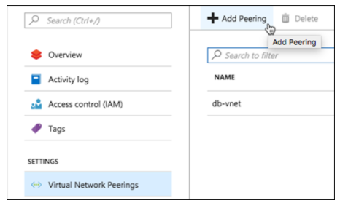

**VNet Injection**

If you're looking to do specific network customizations, you could deploy Azure Databricks data plane resources in your own VNet. In this scenario, instead of using the managed VNet, which restricts you from making changes, you "bring your own" VNet where you have full control. Azure Databricks will still create the managed VNet, but it will not use it.

Features enabled through [VNet injection](https://docs.microsoft.com/en-us/azure/databricks/administration-guide/cloud-configurations/azure/vnet-inject) include:

• On-Premises Data Access

• Single-IP SNAT and Firewall-based filtering via custom routing

• Service Endpoint

To enable VNet injection, select the **Deploy Azure Databricks workspace in your own Virtual Network** option when provisioning your Azure Databricks workspace.

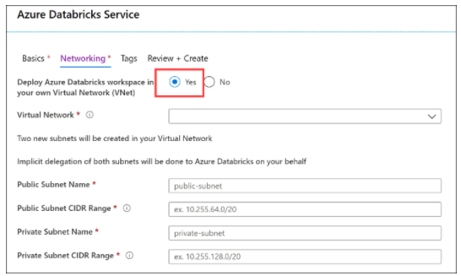

When you compare the deployed Azure Databricks resources in a VNet injection deployment vs. the standard deployment you saw earlier, there are some slight differences. The primary difference is that the clusters in the Data Plane are hosted within a customer-managed Azure Databricks workspace VNet instead of a Microsoft-managed one. The Control Plane is still hosted within a Microsoft-managed VNet, but the TLS connection is still created for you that routes traffic between both VNets. However, the network security groups (NSG) becomes customer-managed as well in this configuration. The only resource in the Data Plane that is still managed by Microsoft is the Blob Storage service that provides DBFS.

Also, inter-node TLS communication between the clusters in the Data Plane is enabled in this deployment. One thing to note is that, while inter-node TLS is more secure, there is a slight impact on performance vs. the non-inter-node TLS found in a basic deployment.

If your Azure Databricks workspace is deployed to your own virtual network (VNet), you can use custom routes, also known as [user-defined routes](https://docs.microsoft.com/en-us/azure/virtual-network/virtual-networks-udr-overview) (UDR), to ensure that network traffic is routed correctly for your workspace. For example, if you connect the virtual network to your on-premises network, traffic may be routed through the on-premises network and unable to reach the Azure Databricks control plane. User-defined routes can solve that problem. The diagram below shows UDRs, as well as the other components of a VNet injection deployment.

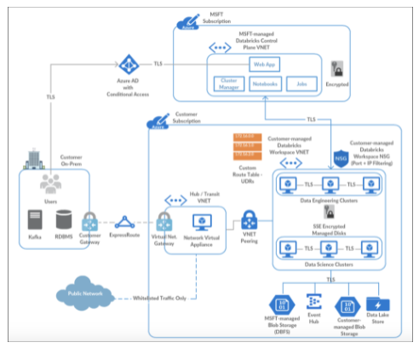

You can create different Azure Databricks workspaces in the same VNet. However, you will need separate pairs of dedicated subnets per Azure Databricks workspace. As such, the VNet network range has to be fairly large to accommodate those. The VNet CIDR can be anywhere between /16 and /24, and the subnet CIDR can be anywhere between /18 and /26.

**Secure connectivity to other Azure data services**

Your Azure Databricks deployment likely includes other Azure data services, such as Azure Blob Storage, Azure Data Lake Storage Gen2, Azure Cosmos DB, and Azure Synapse Analytics. We recommend ensuring traffic between Azure Databricks and Azure data services such as these remains on the Azure network backbone, instead of traversing over the public internet. To do this, you should use Azure Private Link or Service Endpoints.

**Azure Private Link**

Using Azure [Private Link](https://docs.microsoft.com/en-us/azure/private-link/private-link-overview) is currently the most secure way to access Azure data services from Azure Databricks. Private Link enables you to access Azure PaaS Services (for example, Azure Storage, Azure Cosmos DB, and SQL Database) and Azure hosted customer/partner services over a Private Endpoint in your virtual network. Traffic between your virtual network and the service traverses over the Microsoft network backbone, eliminating exposure from the public Internet. You can also create your own Private Link Service in your virtual network (VNet) and deliver it privately to your customers.

**Azure VNet service endpoints**

Virtual Network (VNet) [service endpoints](https://docs.microsoft.com/en-us/azure/virtual-network/virtual-network-service-endpoints-overview) extend your virtual network private address space. The endpoints also extend the identity of your VNet to the Azure services over a direct connection. Endpoints allow you to secure your critical Azure service resources to only your virtual networks. Traffic from your VNet to the Azure service always remains on the Microsoft Azure network backbone.

**Combining VNet injection and Private Link**

The following diagram shows how you may use Private Link in combination with VNet injection in a [hub and spoke topology](https://docs.microsoft.com/en-us/azure/architecture/reference-architectures/hybrid-networking/hub-spoke) to prevent data exfiltration:

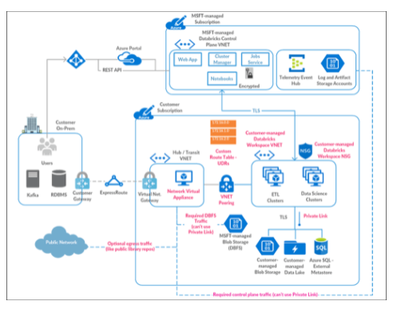

**Compliance**

In many industries, it is imperative to maintain compliance through a combination of following best practices in storing and handling data, and by using services that maintain compliance certifications and attestations.

Azure Databricks has the following compliance certifications:

• HITRUST

• AICPA

• PCI DSS

• ISO 27001

• ISO 27018

• HIPAA (Covered by MSFT Business Associates Agreement (BAA))

• SOC2, Type 2

**Audit logs**

Databricks provides comprehensive end-to-end audit logs of activities performed by Databricks users, allowing your enterprise to monitor detailed Databricks usage patterns. Azure Monitor integration enables you to capture the audit logs and make then centrally available and fully searchable.

Services / Entities included are:

• Accounts

• Clusters

• DBFS

• Genie

• Jobs

• ACLs

• SSH

• Tables

<https://docs.microsoft.com/en-us/azure/security/fundamentals/network-overview>

Bottom of Form

Top of Form

Question 26: Skipped

Large data projects can be complex. The projects often involve hundreds of decisions. Multiple people are typically involved, and each person helps take the project from design to production.

Roles such as business stakeholders, business analysts, and business intelligence developers are well known and valuable.

Which of the available roles is best described by the following:

*“Provisions and sets up data platform technologies that are on-premises and in the cloud. They manage and secure the flow of structured and unstructured data from multiple sources. The data platforms they use can include relational databases, nonrelational databases, data streams, and file stores. They ensure that data services securely and seamlessly integrate with other data platform technologies or application services such as Azure Cognitive Services, Azure Search, or even bots.”*

* ​

AI Engineer

* ​

Solution Architects

* ​

RPA Developers

* ​

Project Manager

* ​

BI Engineer

* ​

Data Engineer

**(Correct)**

* ​

Data Scientist

* ​

System Administrators

**Explanation**

**Data Engineer**

Data engineers primarily provision data stores. They make sure that massive amounts of data are securely and cost-effectively extracted, loaded, and transformed.

Data engineers provision and set up data platform technologies that are on-premises and in the cloud. They manage and secure the flow of structured and unstructured data from multiple sources. The data platforms they use can include relational databases, nonrelational databases, data streams, and file stores. Data engineers also ensure that data services securely and seamlessly integrate with other data platform technologies or application services such as Azure Cognitive Services, Azure Search, or even bots.

The Azure data engineer focuses on data-related tasks in Azure. Primary responsibilities include using services and tools to ingest, egress, and transform data from multiple sources. Azure data engineers collaborate with business stakeholders to identify and meet data requirements. They design and implement solutions. They also manage, monitor, and ensure the security and privacy of data to satisfy business needs.

The role of data engineer is different from the role of a database administrator. A data engineer's scope of work goes well beyond looking after a database and the server where it's hosted. Data engineers must also get, ingest, transform, validate, and clean up data to meet business requirements. This process is called *data wrangling*.

A data engineer adds tremendous value to both business intelligence and data science projects. Data wrangling can consume a lot of time. When the data engineer wrangles data, projects move more quickly because data scientists can focus on their own areas of work.

Both database administrators and business intelligence professionals can easily transition to a data engineer role. They just need to learn the tools and technology that are used to process large amounts of data.

<https://www.whizlabs.com/blog/azure-data-engineer-roles/>

Bottom of Form

Top of Form

Question 27: Skipped

Identify the missing word(s) in the following sentence within the context of Microsoft Azure.

[?] data is typically stored in a relational database such as SQL Server or Azure SQL Database.

* ​

Structured

**(Correct)**

* ​

Unstructured

* ​

Semi-structured

* ​

JSON Format

**Explanation**

Depending on the type of data such as structured, semi-structured, or unstructured, data will be stored differently. Structured data is typically stored in a relational database such as SQL Server or Azure SQL Database. Azure SQL Database is a service that runs in the cloud.

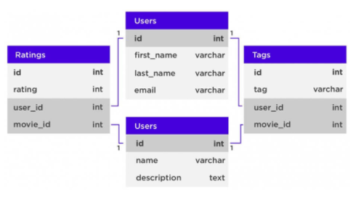

You can use it to create and access relational tables. The service is managed and run by Azure, you just specify that you want a database server to be created. The act of setting up the database server is called *provisioning*.

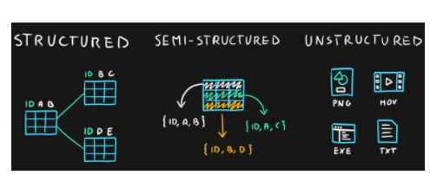

<https://f5a395285c.nxcli.net/microsoft-azure/dp-900/structured-data-vs-unstructured-data-vs-semi-structured-data/>

Bottom of Form

Top of Form

Question 28: Skipped

Across all organizations and industries, common use cases for Azure Synapse Analytics are which of the following? (Select all that apply)

* ​

AI learning troubleshooting

* ​

Integrated analytics

**(Correct)**

* ​

Real time analytics

**(Correct)**

* ​

Advanced analytics

**(Correct)**

* ​

Data exploration and discovery

**(Correct)**

* ​

Modern data warehousing

**(Correct)**

* ​

Data integration

**(Correct)**

* ​

IoT device deployment

**Explanation**

Across all organizations and industries, the common use cases for Azure Synapse Analytics are identified by the need for:

**Modern data warehousing**

This involves the ability to integrate all data, including big data, to reason over data for analytics and reporting purposes from a descriptive analytics perspective, independent of its location or structure.

**Advanced analytics**

Enables organizations to perform predictive analytics using both the native features of Azure Synapse Analytics, and integrating with other technologies such as Azure Databricks.

**Data exploration and discovery**

The SQL serverless functionality provided by Azure Synapse Analytics enables Data Analysts, Data Engineers and Data Scientist alike to explore the data within your data estate. This capability supports data discovery, diagnostic analytics, and exploratory data analysis.

**Real time analytics**

Azure Synapse Analytics can capture, store and analyze data in real-time or near-real time with features such as Azure Synapse Link, or through the integration of services such as Azure Stream Analytics and Azure Data Explorer.

**Data integration**

Azure Synapse Pipelines enables you to ingest, prepare, model and serve the data to be used by downstream systems. This can be used by components of Azure Synapse Analytics exclusively.

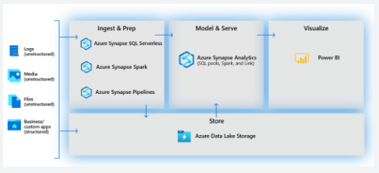

It can also interact with existing Azure services that you may already have in place for your existing analytical solutions.

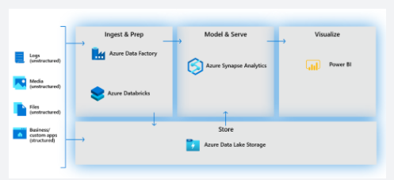

**Integrated analytics**

With the variety of analytics that can be performed on the data at your disposal, putting together the services in a cohesive solution can be a complex operation. Azure Synapse Analytics removes this complexity by integrating the analytics landscape into on service. That way you can spend more time working with the data to bring business benefit, than spending much of your time provisioning and maintaining multiple systems to achieve the same outcomes.

<https://docs.microsoft.com/en-us/azure/synapse-analytics/overview-what-is>

Bottom of Form

Top of Form

Question 29: Skipped

Which technology is typically used as a staging area in a modern data warehousing architecture?

* ​

Azure Synapse SQL Pools

* ​

Azure Data Pools

* ​

Azure Data Lake

**(Correct)**

* ​

Azure Synapse Spark Lakes

* ​

Azure Synapse Spark Pools

* ​

Azure Synapse SQL Lakes

**Explanation**

Azure Data Lake Store Gen 2 is the technology that will be used to stage data before loading it into the various components of Azure Synapse Analytics.

Azure Data Lake Storage Gen2 is a set of capabilities dedicated to big data analytics, built on [Azure Blob storage](https://docs.microsoft.com/en-us/azure/storage/blobs/storage-blobs-introduction).

Data Lake Storage Gen2 converges the capabilities of [Azure Data Lake Storage Gen1](https://docs.microsoft.com/en-us/azure/data-lake-store/) with Azure Blob storage. For example, Data Lake Storage Gen2 provides file system semantics, file-level security, and scale. Because these capabilities are built on Blob storage, you'll also get low-cost, tiered storage, with high availability/disaster recovery capabilities.

<https://docs.microsoft.com/en-us/azure/storage/blobs/data-lake-storage-introduction>

Bottom of Form

Top of Form

Question 30: Skipped

In some cases, the code-free transformation at scale may not meet your requirements. You can use Azure Data Factory to ingest raw data collected from different sources and work with a range of compute resources such as Azure Databricks.

The following steps are required when implementing data ingestion and transformation using the collective capabilities of Azure Data Factory and Azure Databricks.

The order of the below steps has been shuffled.

a. Perform analysis on data

b. Create Azure storage account

c. Create data workflow pipeline

d. Create an Azure Data Factory

e.  Add Databricks notebook to pipeline

Select the correct step order from the below.

* ​

b → c → d → e → a

* ​

b → d → c → e → a

**(Correct)**

* ​

c → b → d → e → a

* ​

b → d → c → a → e

**Explanation**

**The correct order is: b → d → c → e → a**

In some cases, the code-free transformation at scale may not meet your requirements. You can use Azure Data Factory to ingest raw data collected from different sources and work with a range of compute resources such as Azure Databricks, Azure HDInsight, or other compute resources to restructure it as per your requirements.

**ADF and Azure Databricks**

As an example, the integration of Azure Databricks with ADF allows you to add Databricks notebooks within an ADF pipeline to leverage the analytical and data transformation capabilities of Databricks. You can add a notebook within your data workflow to structure and transform raw data loaded into ADF from different sources. Once the data is transformed using Databricks, you can then load it to any data warehouse source.

Data ingestion and transformation using the collective capabilities of ADF and Azure Databricks essentially involves the following steps:

1.**Create Azure storage account** - The fist step is to create an Azure storage account to store your ingested and transformed data.

2.**Create an Azure Data Factory** - Once you have your storage account setup, you need to create your Azure Data Factory using Azure portal.

3.**Create data workflow pipeline** - After your storage and ADF is up and running, you start by creating a pipeline, where the first step is to copy data from your source using ADF's Copy activity. Copy Activity allows you to copy data from different on-premises and cloud sources.

4.**Add Databricks notebook to pipeline** - Once your data is copied to ADF, you add your Databricks notebook to the pipeline, after copy activity. This notebook may contain syntax and code to transform and clean raw data as required.

5.**Perform analysis on data** - Now that your data is cleaned up and structured into the required format, you can use Databricks notebooks to further train or analyze it to output required results.

<https://azure.microsoft.com/en-us/blog/operationalize-azure-databricks-notebooks-using-data-factory/>

Bottom of Form

Top of Form

Question 31: Skipped

What are Azure Synapse Studio notebooks based on?

* ​

SQL Pool

* ​

Spark Pool

* ​

T-SQL

* ​

Spark

**(Correct)**

**Explanation**

Azure Synapse Studio notebook is purely Spark based.

<https://docs.microsoft.com/en-us/azure/synapse-analytics/spark/apache-spark-development-using-notebooks?tabs=classical>

Bottom of Form

Top of Form

Question 32: Skipped

What does the CD in CI/CD mean?

* ​

Continuous Deployment

* ​

Control Data

* ​

Both Continuous Deployment & Continuous Delivery

**(Correct)**

* ​

Continuous Delivery

* ​

Community Development

* ​

Both Control Data & Continuous Delivery

**Explanation**

While Agile, CI/CD, and DevOps are different, they support one another. Agile focuses on the development process, CI/CD on practices, and DevOps on culture.

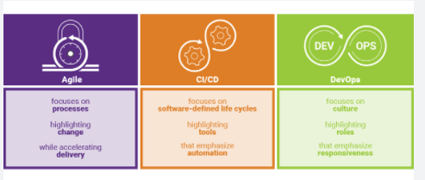

**• Agile** focuses on processes highlighting change while accelerating delivery.

**• CI/CD** focuses on software-defined life cycles highlighting tools that emphasize automation.

**• DevOps** focuses on culture highlighting roles that emphasize responsiveness.

<https://www.synopsys.com/blogs/software-security/agile-cicd-devops-difference/>

Azure DevOps is a collection of services that provide an end-to-end solution for the five core practices of DevOps: planning and tracking, development, build and test, delivery, and monitoring and operations.

It is possible to put an Azure Databricks Notebook under Version Control in an Azure Devops repo. Using Azure DevOps, you can then build Deployment pipelines to manage your release process.

**CI/CD with Azure DevOps**

Here are some of the features that make it well-suited to CI/CD with Azure Databricks.

• Integrated Git repositories

• Integration with other Azure services

• Automatic virtual machine management for testing builds

• Secure deployment

• Friendly GUI that generates (and accepts) various scripted files

**But what is CI/CD?**

**Continuous Integration**

Throughout the development cycle, developers commit code changes locally as they work on new features, bug fixes, etc. If the developers practice continuous integration, they merge their changes back to the main branch as often as possible. Each merge into the master branch triggers a build and automated tests that validate the code changes to ensure successful integration with other incoming changes. This process avoids integration headaches that frequently happen when people wait until the release day before they merge all their changes into the release branch.

**Continuous Delivery**

Continuous delivery builds on top of continuous integration to ensure you can successfully release new changes in a fast and consistent way. This is because, in addition to the automated builds and testing provided by continuous integration, the release process is automated to the point where you can deploy your application with the click of a button.

**Continuous Deployment**

Continuous deployment takes continuous delivery a step further by automatically deploying your application without human intervention. This means that merged changes pass through all stages of your production pipeline and, unless any of the tests fail, automatically release to production in a fully automated manner.

**Continuous Delivery automates your release process up to the point where human intervention is needed, by clicking a button. Continuous Deployment takes a step further by removing the human intervention and relying on automated tests to automatically determine whether the build should be deployed into production.**

**Who benefits?**

*Everyone*. Once properly configured, automated testing and deployment can free up your engineering team and enable your data team to push their changes into production. For example:

• Data engineers can easily deploy changes to generate new tables for BI analysts.

• Data scientists can update models being used in production.

• Data analysts can modify scripts being used to generate dashboards.

In short, changes made to a Databricks notebook can be pushed to production with a simple mouse click (and then any amount of oversight that your DevOps team feels is appropriate).

<https://docs.microsoft.com/en-us/azure/devops/user-guide/alm-devops-features?view=azure-devops>

Bottom of Form

Top of Form

Question 33: Skipped

Most Azure Data Factory users develop using the user experience. Azure Data Factory is available in a variety of software development kits (SDKs) for anyone who wish to develop programmatically.

Which of the following allow programmatic interaction with Azure Data Factory?

* ​

REST APIs

**(Correct)**

* ​

Python

**(Correct)**

* ​

JavaScript

* ​

.NET

**(Correct)**

* ​

Java

* ​

C++

* ​

C#

* ​

ARM Templates

**(Correct)**

* ​

PowerShell

**(Correct)**

**Explanation**

While most Azure Data Factory users develop using the user experience, Azure Data Factory is available in a variety of software development kits (SDKs) for anyone who wish to develop programmatically. When using an SDK, a user works directly against the Azure Data Factory service and all updates are immediately applied to the factory.

**It is possible to interact programmatically with Azure Data Factory using the following languages and SDKs:**

**• Python**

**• .NET**

**• REST APIs**

**• PowerShell**

**• Azure Resource Manager Templates**

**• Data flow scripts**

Data flow script (DFS) is the underlying metadata, similar to a coding language, that is used to execute the transformations that are included in a mapping data flow. Every transformation is represented by a series of properties that provide the necessary information to run the job properly. The script is visible and editable from ADF by clicking on the "script" button on the top ribbon of the browser UI.

<https://docs.microsoft.com/en-us/azure/data-factory/monitor-programmatically>

Bottom of Form

Top of Form

Question 34: Skipped

Identify the missing word(s) in the following sentence within the context of Microsoft Azure.

[?] describes the final cost of owning a given technology. In on-premises systems, [?] includes the following costs:

• Hardware

• Software licensing

• Labour (installation, upgrades, maintenance)

• Datacentre overhead (power, telecommunications, building, heating and cooling)

* ​

MTD

* ​

TCO

**(Correct)**

* ​

RPO

* ​

RTO

**Explanation**

**Total cost of ownership**

The term *total cost of ownership* (TCO) describes the final cost of owning a given technology. In on-premises systems, TCO includes the following costs:

• Hardware

• Software licensing

• Labour (installation, upgrades, maintenance)

• Datacentre overhead (power, telecommunications, building, heating and cooling)

It's difficult to align on-premises expenses with actual usage. Organizations buy servers that have extra capacity so they can accommodate future growth. A newly purchased server will always have excess capacity that isn't used. When an on-premises server is at maximum capacity, even an incremental increase in resource demand will require the purchase of more hardware.

Because on-premises server systems are very expensive, costs are often *capitalized*. This means that on financial statements, costs are spread out across the expected lifetime of the server equipment. Capitalization restricts an IT manager's ability to buy upgraded server equipment during the expected lifetime of a server. This restriction limits the server system's ability to accommodate increased demand.

In cloud solutions, expenses are recorded on the financial statements each month. They're monthly expenses instead of capital expenses. Because subscriptions are a different kind of expense, the expected server lifetime doesn't limit the IT manager's ability to upgrade to meet an increase in demand.

<https://www.purchasing-procurement-center.com/total-cost-of-ownership.html>

Bottom of Form

Top of Form

Question 35: Skipped

Within the context of an Azure Databricks workspace, which command orders by a column in descending order?

* ​

df.orderBy("requests").desc()

* ​

df.orderBy("requests desc")

* ​

df.orderBy("requests").show.desc()

* ​

df.orderBy(col("requests").desc())

**(Correct)**

**Explanation**

Use the .desc() method on the Column Class to reverse the order.

<https://sparkbyexamples.com/pyspark/pyspark-orderby-and-sort-explained/>

Bottom of Form

Top of Form

Question 36: Skipped

**Scenario:** You have been contracted by Wayne Enterprises, a company owned by Bruce Wayne with market value of over twenty seven million dollars. Bruce founded Wayne Enterprises shortly after he created the Wayne Foundation and he became the president and chairman of the company.

Bruce has come to you because his IT team plans to use Microsoft Azure Synapse Analytics.

The IT team is lead by Oswald Cobblepot and his team created a table named SalesFact in an enterprise data warehouse in Azure Synapse Analytics. SalesFact contains sales data from the past 36 months and has the following characteristics:  
• Is partitioned by month  
• Contains one billion rows  
• Has clustered columnstore indexes  
At the beginning of each month, Bruce requires that the team removes data from SalesFact that is older than 36 months as quickly as possible.  
The following is a list of items which Oswald believe he should action, but he is not sure which to use, nor which order to execute the actions in.

a. Switch the partition containing the stale data from SaleFact to SalesFact_Work.

b. Truncate the partition containing the stale data.

c. Drop the SalesFact_Work table.

d. Create an empty table named SalesFact_Work that has the same schema as SalesFact.

e. Execute s DELETE statement where the value in the Date column is more than 36 months ago.

f. Copy the data to a new table by using CREATE TABLE AS SELECT.

Which actions should Oswald perform in sequence in a stored procedure?

* ​

f → a → b

* ​

f → e

* ​

d → a → c

**(Correct)**

* ​

f → b → c

**Explanation**

*The correct items and sequence is d → a → c.*

**Step 1:** Create an empty table named SalesFact_work that has the same schema as SalesFact.  
**Step 2:**Switch the partition containing the stale data from SalesFact to SalesFact_Work.  
SQL Data Warehouse supports partition splitting, merging, and switching. To switch partitions between two tables, you must ensure that the partitions align on their respective boundaries and that the table definitions match.  
Loading data into partitions with partition switching is a convenient way stage new data in a table that is not visible to users the switch in the new data.  
**Step 3:** Drop the SalesFact_Work table.

**What are table partitions?**

Table partitions enable you to divide your data into smaller groups of data. In most cases, table partitions are created on a date column. Partitioning is supported on all dedicated SQL pool table types; including clustered columnstore, clustered index, and heap. Partitioning is also supported on all distribution types, including both hash or round robin distributed.

Partitioning can benefit data maintenance and query performance. Whether it benefits both or just one is dependent on how data is loaded and whether the same column can be used for both purposes, since partitioning can only be done on one column.

**Benefits to loads**

The primary benefit of partitioning in dedicated SQL pool is to improve the efficiency and performance of loading data by use of partition deletion, switching and merging. In most cases data is partitioned on a date column that is closely tied to the order in which the data is loaded into the SQL pool. One of the greatest benefits of using partitions to maintain data is the avoidance of transaction logging. While simply inserting, updating, or deleting data can be the most straightforward approach, with a little thought and effort, using partitioning during your load process can substantially improve performance.

Partition switching can be used to quickly remove or replace a section of a table. For example, a sales fact table might contain just data for the past 36 months. At the end of every month, the oldest month of sales data is deleted from the table. This data could be deleted by using a delete statement to delete the data for the oldest month.

However, deleting a large amount of data row-by-row with a delete statement can take too much time, as well as create the risk of large transactions that take a long time to rollback if something goes wrong. A more optimal approach is to drop the oldest partition of data. Where deleting the individual rows could take hours, deleting an entire partition could take seconds.

**Benefits to queries**

Partitioning can also be used to improve query performance. A query that applies a filter to partitioned data can limit the scan to only the qualifying partitions. This method of filtering can avoid a full table scan and only scan a smaller subset of data. With the introduction of clustered columnstore indexes, the predicate elimination performance benefits are less beneficial, but in some cases there can be a benefit to queries.

For example, if the sales fact table is partitioned into 36 months using the sales date field, then queries that filter on the sale date can skip searching in partitions that don't match the filter.

**Sizing partitions**

While partitioning can be used to improve performance some scenarios, creating a table with **too many** partitions can hurt performance under some circumstances. These concerns are especially true for clustered columnstore tables.

For partitioning to be helpful, it is important to understand when to use partitioning and the number of partitions to create. There is no hard fast rule as to how many partitions are too many, it depends on your data and how many partitions you loading simultaneously. A successful partitioning scheme usually has tens to hundreds of partitions, not thousands.

When creating partitions on **clustered columnstore** tables, it is important to consider how many rows belong to each partition. For optimal compression and performance of clustered columnstore tables, a minimum of 1 million rows per distribution and partition is needed. Before partitions are created, dedicated SQL pool already divides each table into 60 distributed databases.

Any partitioning added to a table is in addition to the distributions created behind the scenes. Using this example, if the sales fact table contained 36 monthly partitions, and given that a dedicated SQL pool has 60 distributions, then the sales fact table should contain 60 million rows per month, or 2.1 billion rows when all months are populated. If a table contains fewer than the recommended minimum number of rows per partition, consider using fewer partitions in order to increase the number of rows per partition.  
<https://docs.microsoft.com/en-us/azure/sql-data-warehouse/sql-data-warehouse-tables-partition>

Bottom of Form

Top of Form

Question 37: Skipped

**Scenario:** You are working as a consultant at Avengers Security. At the moment, you are consulting with Tony, the lead of the IT team and the topic of discussion is about altering a table in an Azure Synapse Analytics dedicated SQL pool based on some specific requirements.

Happy Hogan, the lead developer, has created a table by using the following Transact-SQL statement.

1. CREATE TABLE [dbo].[DimEmployee](
2. [EmployeeKey] [int] IDENTITY (1,1) NOT NULL,
3. [EmployeeID] [int] NOT NULL,
4. [FirstName] [varchar] (100) NOT NULL,
5. [LastName] [varchar] (100) NOT NULL,
6. [JobTitle] [varchar] (100) NOT NULL,
7. [LastHireDate] [date] NULL,
8. [StreetAddress] [varchar] (500) NOT NULL,
9. [City] [varchar] (200) NOT NULL,
10. [ProvinceState] [varchar] (50) NOT NULL,
11. [PostalCode] [varchar] (10) NOT NULL,
12. )

**Required:**

The table must be altered to meet the following items:

1.  It must ensure that users can identify the current manager of any employee.

2.  It must support creating an employee reporting hierarchy for the entire company.

3.  It must provide a simple lookup of the managers' attributes (name and job title).

Which column should be added to the table?

* ​

[ManagerEmployeeKey] [int] NULL

**(Correct)**

* ​

[ManagerName] [varchar](200) NULL

* ​

[ManagerEmployeeKey] [int] NULL

* ​

[ManagerEmployeeID] [int] NULL

**Explanation**

[ManagerEmployeeKey] [int] NULL  is the correct line to add to the table. In dimensions we use surrogates. If [ManagerEmployeeID] [int] NULL is used to create a hierarchy, at the time of the insert we can’t guarantee that the manager is already inserted and thus we can’t resolve the EmployeeKey of the manager, because it is an identity.

Hierarchies, in tabular models, are metadata that define relationships between two or more columns in a table. Hierarchies can appear separate from other columns in a reporting client field list, making them easier for client users to navigate and include in a report.

**Benefits**

Tables can include dozens or even hundreds of columns with unusual column names in no apparent order. This can lead to an unordered appearance in reporting client field lists, making it difficult for users to find and include data in a report. Hierarchies can provide a simple, intuitive view of an otherwise complex data structure.

For example, in a Date table, you can create a Calendar hierarchy. Calendar Year is used as the top-most parent level, with Month, Week, and Day included as child levels (Calendar Year->Month->Week->Day). This hierarchy shows a logical relationship from Calendar Year to Day. A client user can then select Calendar Year from a Field List to include all levels in a PivotTable, or expand the hierarchy, and select only particular levels to be included in the PivotTable.

Because each level in a hierarchy is a representation of a column in a table, the level can be renamed. While not exclusive to hierarchies (any column can be renamed in a tabular model), renaming hierarchy levels can make it easier for users to find and include levels in a report. Renaming a level does not rename the column it references; it simply makes the level more identifiable. In our Calendar Year hierarchy example, in the Date table in Data View, the columns: CalendarYear, CalendarMonth, CalendarWeek, and CalendarDay were renamed to Calendar Year, Month, Week, and Day to make them more easily identifiable. Renaming levels has the additional benefit of providing consistency in reports, since users will less likely need to change column names to make them more readable in PivotTables, charts, etc.

Hierarchies can be included in perspectives. Perspectives define viewable subsets of a model that provide focused, business-specific, or application-specific viewpoints of the model. A perspective, for example, could provide users a viewable list (hierarchy) of only those data items necessary for their specific reporting requirements. For more information, see [Perspectives](https://docs.microsoft.com/en-us/analysis-services/tabular-models/perspectives-ssas-tabular?view=asallproducts-allversions).

Hierarchies are not meant to be used as a security mechanism, but as a tool for providing a better user experience. All security for a particular hierarchy is inherited from the underlying model. Hierarchies cannot provide access to model objects to which a user does not already have access. Security for the model database must be resolved before access to objects in the model can be provided through a hierarchy. Security roles can be used to secure model metadata and data. For more information, see [Roles](https://docs.microsoft.com/en-us/analysis-services/tabular-models/roles-ssas-tabular?view=asallproducts-allversions).

Defining hierarchies

You create and manage hierarchies by using the model designer in Diagram View. Creating and managing hierarchies is not supported in the model designer in Data View. To view the model designer in Diagram View, click the **Model** menu, then point to **Model View**, and then click **Diagram View**.

To create a hierarchy, right-click a column you want to specify as the parent level, and then click **Create Hierarchy**. You can multi-select any number of columns (within a single table) to include, or you can later add columns as child levels by clicking and dragging columns to the parent level. When multiple columns are selected, columns are automatically placed in an order based on cardinality. You can change the order by clicking and dragging a column (level) to a different order or by using Up and Down navigation controls on the context menu. When adding a column as a child level, you can use auto-detect by dragging and dropping the column onto the parent level.

A column can appear in more than one hierarchy. Hierarchies cannot include non-column objects such as measures or KPIs. A hierarchy can be based on columns from within a single table only. If you multi-select a measure along with one or more columns, or if you select columns from multiple tables, the **Create Hierarchy** command is disabled in the context menu. To add a column from a different table, use the RELATED DAX function to add a calculated column that references the column from the related table. The function uses the following syntax: =RELATED(TableName[ColumnName]). For more information, see RELATED Function.

By default, new hierarchies are named hierarchy1, hierarchy 2, etc. You should change hierarchy names to reflect the nature of the parent-child relationship, making them more identifiable to users.

<https://docs.microsoft.com/en-us/analysis-services/tabular-models/hierarchies-ssas-tabular?view=asallproducts-allversions>

Bottom of Form

Top of Form

Question 38: Skipped

How do you perform UPSERT in a Delta dataset?

* ​

Use UPSERT INTO my-table /MERGE

* ​

Use UPSERT INTO my-table

* ​

Use MODIFY my-table UPSERT INTO data-to-upsert

* ​

Use MERGE INTO my-table USING data-to-upsert

**(Correct)**

**Explanation**

Use the MERGE INTO my-table USING data-to-upsert syntax to perform UPSERT in a Databricks Delta dataset.

<https://www.databasejournal.com/features/mssql/using-the-merge-statement-to-perform-an-upsert.html>

Bottom of Form

Top of Form

Question 39: Skipped

See the following code:

1. SQL
2. COPY INTO dbo.[lineitem] FROM 'https://unsecureaccount.blob.core.windows.net/customerdatasets/folder1/lineitem.csv’

What is this code created to do?

* ​

Move data from a private storage account

* ​

Load data from a public storage account

**(Correct)**

* ​

Load data from a private storage account

* ​

Move data from a public storage account

**Explanation**

The broad capabilities of the Copy Activity allow you to quickly and easily move data into SQL Pools from a variety of sources.

In Azure Data Factory, you can use the Copy activity to copy data among data stores located on-premises and in the cloud. After you copy the data, you can use other activities to further transform and analyze it. You can also use the Copy activity to publish transformation and analysis results for business intelligence (BI) and application consumption.

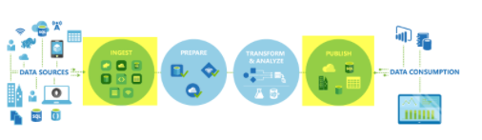

The Copy activity is executed on an [integration runtime](https://docs.microsoft.com/en-us/azure/data-factory/concepts-integration-runtime). You can use different types of integration runtimes for different data copy scenarios:

• When you're copying data between two data stores that are publicly accessible through the internet from any IP, you can use the Azure integration runtime for the copy activity. This integration runtime is secure, reliable, scalable, and [globally available](https://docs.microsoft.com/en-us/azure/data-factory/concepts-integration-runtime).

• When you're copying data to and from data stores that are located on-premises or in a network with access control (for example, an Azure virtual network), you need to set up a self-hosted integration runtime.

An integration runtime needs to be associated with each source and sink data store. For information about how the Copy activity determines which integration runtime to use, see [Determining which IR to use](https://docs.microsoft.com/en-us/azure/data-factory/concepts-integration-runtime).

To copy data from a source to a sink, the service that runs the Copy activity performs these steps:

1.Reads data from a source data store.

2.Performs serialization/deserialization, compression/decompression, column mapping, and so on. It performs these operations based on the configuration of the input dataset, output dataset, and Copy activity.

3.Writes data to the sink/destination data store.

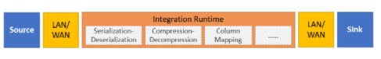

The Copy Activity supports a large range of data sources and sinks on-premises and in the cloud. It facilitates the efficient, yet flexible parsing and transfer of data or files between systems in an optimized fashion as well as giving you capability of easily converting datasets into other formats.

**In the following example, you can load data from a public storage account.**Here the COPY statement's defaults match the format of the line item csv file.

SQL

COPY INTO dbo.[lineitem] FROM 'https://unsecureaccount.blob.core.windows.net/customerdatasets/folder1/lineitem.csv'

The default values for csv files of the COPY command are:

• DATEFORMAT = Session DATEFORMAT

• MAXERRORS = 0

• COMPRESSION default is uncompressed

• FIELDQUOTE = “”

• FIELDTERMINATOR = “,”

• ROWTERMINATOR = ‘\n’

• FIRSTROW = 1

• ENCODING = ‘UTF8’

• FILE_TYPE = ‘CSV’

• IDENTITY_INSERT = ‘OFF’

<https://docs.microsoft.com/en-us/azure/data-factory/copy-activity-overview>

Bottom of Form

Top of Form

Question 40: Skipped

Integration Runtime (IR) is the compute infrastructure used by Azure Data Factory. It provides data integration capabilities across different network environments. Data Factory offers three types of Integration Runtime.

These three IR types are:

• Azure

• Self-hosted

• Azure-SSIS

Which does not have Private network support?

* ​

None of the listed options.

* ​

Azure-SSIS

* ​

All the listed options.

* ​

Self-hosted

* ​

Azure

**(Correct)**

**Explanation**

In Data Factory, an activity defines the action to be performed. A linked service defines a target data store or a compute service. An integration runtime provides the infrastructure for the activity and linked services.

Integration Runtime is referenced by the linked service or activity, and provides the compute environment where the activity either runs on or gets dispatched from. This way, the activity can be performed in the region closest possible to the target data store or compute service in the most performant way while meeting security and compliance needs.

In short, the Integration Runtime (IR) is the compute infrastructure used by Azure Data Factory. It provides the following data integration capabilities across different network environments, including:

**• Data Flow**: Execute a Data Flow in managed Azure compute environment.

**• Data movement**: Copy data across data stores in public network and data stores in private network (on-premises or virtual private network). It provides support for built-in connectors, format conversion, column mapping, and performant and scalable data transfer.

**• Activity dispatch**: Dispatch and monitor transformation activities running on a variety of compute services such as Azure Databricks, Azure HDInsight, Azure Machine Learning, Azure SQL Database, SQL Server, and more.

**• SSIS package execution**: Natively execute SQL Server Integration Services (SSIS) packages in a managed Azure compute environment.

Whenever an Azure Data Factory instance is created, a default Integration Runtime environment is created that supports operations on cloud data stores and compute services in public network. This can be viewed when the integration runtime is set to Auto-Resolve.

**Integration runtime types**

Data Factory offers three types of Integration Runtime, and you should choose the type that best serve the data integration capabilities and network environment needs you are looking for. These three types are:

• Azure

• Self-hosted

• Azure-SSIS

You can explicitly define the Integration Runtime setting in the **connectVia** property, if this is not defined, then the default Integration Runtime is used with the property set to Auto-Resolve.

The following describes the capabilities and network support for each of the integration runtime types:

**IR type:** Azure

**Public network:** Data Flow Data movement Activity dispatch

**Private network:** --

**IR type:** Self-hosted

**Public network:** Data movement Activity dispatch

**Private network:** Data movement Activity dispatch

**IR type:** Azure-SSIS

**Public network:** SSIS package execution

**Private network:** SSIS package execution

<https://docs.microsoft.com/en-us/azure/data-factory/concepts-integration-runtime>

Bottom of Form

Top of Form

Question 41: Skipped

In Azure Synapse Studio, the Develop hub is where you access which of the following? (Select four)

* ​

Provisioned SQL pool databases

* ​

External data sources

* ​

Activities

* ​

SQL scripts

**(Correct)**

* ​

Pipeline canvas

* ​

Master Pipeline

* ​

SQL serverless databases

* ​

Data flows

**(Correct)**

* ​

Power BI

**(Correct)**

* ​

Notebooks

**(Correct)**

**Explanation**

In Azure Synapse Studio, the Develop hub is where you manage SQL scripts, Synapse notebooks, data flows, and Power BI reports.

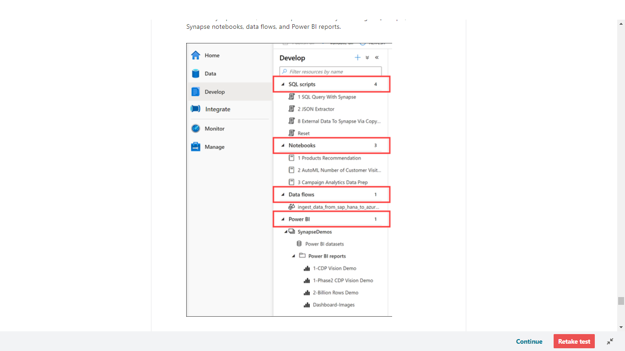

The Develop hub in our sample environment contains examples of the following artifacts:

**• SQL scripts** contains T-SQL scripts that you publish to your workspace. Within the scripts, you can execute commands against any of the provisioned SQL pools or on-demand SQL serverless pools to which you have access.

**• Notebooks** contains Synapse Spark notebooks used for data engineering and data science tasks. When you execute a notebook, you select a Spark pool as its compute target.

**• Data flows** are powerful data transformation workflows that use the power of Apache Spark but are authored using a code-free GUI.

**• Power BI** reports can be embedded here, giving you access to the advanced visualizations they provide without ever leaving the Synapse workspace.

<https://www.techtalkcorner.com/azure-synapse-analytics-develop-hub/>

Bottom of Form

Top of Form

Question 42: Skipped

Blob storage is optimized for storing massive amounts of unstructured data.

What does unstructured mean?

* ​

None of the listed options.

* ​

Blobs can't be organized or named.

* ​

There are no restrictions on the type of data you can store in blobs.

**(Correct)**

* ​

Blobs can't contain structured data, like JSON or XML.

**Explanation**

Azure Blob storage is Microsoft's object storage solution for the cloud. Blob storage is optimized for storing massive amounts of unstructured data. Unstructured data is data that doesn't adhere to a particular data model or definition, such as text or binary data.

<https://docs.microsoft.com/en-us/azure/storage/blobs/storage-blobs-introduction>

Bottom of Form

Top of Form

Question 43: Skipped

Identify the missing word(s) in the following sentence within the context of Microsoft Azure.

**Scenario**: You have created a storage account name using a standardized naming convention within your department.

Your teammate is concerned with this practice because the name of a storage account must be [?].

* ​

Unique within your Azure subscription

* ​

Unique within the containing resource group

* ​

Globally unique

**(Correct)**

* ​

None of the listed options

**Explanation**

The storage account name is used as part of the URI for API access, so it must be globally unique.

<https://docs.microsoft.com/en-us/powershell/module/servicemanagement/azure.service/new-azurestorageaccount?view=azuresmps-4.0.0>

Bottom of Form

Top of Form

Question 44: Skipped

**Scenario:** You are working as a consultant at Advanced Idea Mechanics (A.I.M.) who is a privately funded think tank organized of a group of brilliant scientists whose sole dedication is to acquire and develop power through technological means. Their goal is to use this power to overthrow the governments of the world. They supply arms and technology to radicals and subversive organizations in order to foster a violent technological revolution of society while making a profit.

The company has 10,000 employees. Most employees are located in Europe. The company supports teams worldwide.

AIM has two main locations: a main office in London, England, and a manufacturing plant in Berlin, Germany.

At the moment, you are leading a Workgroup meeting with the IT Team where the topic of discussion is Azure Synapse.

AIM has an Azure Synapse workspace named aimWorkspace that contains an Apache Spark database named aimtestdb.

The lead developer runs the following command in an Azure Synapse Analytics Spark pool in aimWorkspace.

1. CREATE TABLE aimtestdb.aimParquetTable(
2. EmployeeID int,
3. EmployeeName string,
4. EmployeeStartDate date)

Using Parquet the developer then employs Spark to insert a row into aimtestdb.aimParquetTable. The row contains the following data:

[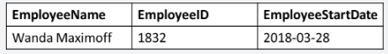](javascript:void(0))

Five minutes later, the developer executes the following query from a serverless SQL pool in aimWorkspace.

1. SELECT EmployeeID -
2. FROM aimtestdb.dbo.aimParquetTable
3. WHERE name = 'Wanda Maximoff';

What will be returned by the query?

* ​

2018-03-28

* ​

1832

* ​

Wanda Maximoff

* ​

An error

**(Correct)**

* ​

A NULL value

**Explanation**

*An error will be thrown because there is a column 'name' in the WHERE clause which doesn't exist in the table.*

The query should be written as:

SELECT EmployeeID -

FROM aimtestdb.dbo.aimParquetTable

WHERE employeename = 'Wanda Maximoff';

Once a database has been created by a Spark job, you can create tables in it with Spark that use Parquet as the storage format. Table names will be converted to lower case and need to be queried using the lower case name. These tables will immediately become available for querying by any of the Azure Synapse workspace Spark pools. They can also be used from any of the Spark jobs subject to permissions.  
*Note: For external tables, since they are synchronized to serverless SQL pool asynchronously, there will be a delay until they appear.*

Azure Synapse Analytics allows the different workspace computational engines to share databases and Parquet-backed tables between its Apache Spark pools and serverless SQL pool.

Once a database has been created by a Spark job, you can create tables in it with Spark that use Parquet as the storage format. Table names will be converted to lower case and need to be queried using the lower case name. These tables will immediately become available for querying by any of the Azure Synapse workspace Spark pools. They can also be used from any of the Spark jobs subject to permissions.

The Spark created, managed, and external tables are also made available as external tables with the same name in the corresponding synchronized database in serverless SQL pool. [Exposing a Spark table in SQL](https://docs.microsoft.com/en-us/azure/synapse-analytics/metadata/table#expose-a-spark-table-in-sql) provides more detail on the table synchronization.

Since the tables are synchronized to serverless SQL pool asynchronously, there will be a delay until they appear.

Manage a Spark created table

Use Spark to manage Spark created databases. For example, delete it through a serverless Apache Spark pool job, and create tables in it from Spark.

If you create objects in such a database from serverless SQL pool or try to drop the database, the operation will fail. The original Spark database cannot be changed via serverless SQL pool.

<https://docs.microsoft.com/en-us/azure/synapse-analytics/metadata/table>

Bottom of Form

Top of Form

Question 45: Skipped

**True or False:**Materialized views are prewritten queries with joins and filters whose definition is saved and the results persisted to both serverless and dedicated SQL pools.

* ​

True

* ​

False

**(Correct)**

**Explanation**

**Materialized views are prewritten queries with joins and filters whose definition is saved and the results persisted to a dedicated SQL pool. They are not supported by serverless SQL pools.**

Materialized views results in increased performance since the data within the view can be fetched without having to resolve the underlying query to base tables. You can also further filter and supplement other queries as if it is a table also. In addition, you also can define a different table distribution within the materialized view definition that is different from the table on which it is based.

As a result, you can use Materialized Views to improve the performance of either complex or slow queries. As the data in the underlying base tables change, the data in the materialized view will automatically update without user interaction.

There are several restrictions that you must be aware of before defining a materialized view:

• The SELECT list in the materialized view definition needs to meet at least one of these two criteria:

• The SELECT list contains an aggregate function.

• GROUP BY is used in the Materialized view definition and all columns in GROUP BY are included in the SELECT list. Up to 32 columns can be used in the GROUP BY clause.

• Supported aggregations include MAX, MIN, AVG, COUNT, COUNT_BIG, SUM, VAR, STDEV.

• Only the hash and round_robin table distribution is supported in the definition.

• Only CLUSTERED COLUMNSTORE INDEX is supported by materialized view.

The following is an example of creating a materialized view named myview, using a hash distribution selecting two columns from a table and grouping by them.

SQL

create materialized view mview

with(distribution=hash(col1))

as select col1, col2 from dbo.table group by col1, col2;

<https://docs.microsoft.com/en-us/sql/t-sql/statements/create-materialized-view-as-select-transact-sql?view=azure-sqldw-latest>

Bottom of Form